Initial estuarine response to the nutrient dense Piney Point wastewater discharge into Tampa Bay, Florida

Marcus W. Beck ([mbeck@tbep.org](mailto:mbeck@tbep.org)), Andrew Altieri ([andrew.altieri@essie.ufl.edu](mailto:andrew.altieri@essie.ufl.edu)), Christine Angelini ([christine.angelini@essie.ufl.edu](mailto:christine.angelini@essie.ufl.edu)), Maya C. Burke ([mburke@tbep.org](mailto:mburke@tbep.org)), Jing Chen ([jchen15@usf.edu](mailto:jchen15@usf.edu)), Diana W. Chin ([diwchin@gmail.com](mailto:diwchin@gmail.com)), Emma E. Dontis ([edontis@co.pinellas.fl.us](mailto:edontis@co.pinellas.fl.us)), Jayne Gardiner ([jgardiner@ncf.edu](mailto:jgardiner@ncf.edu)), Jessica Lewis ([jlewis@tbep.org](mailto:jlewis@tbep.org)), Yonggang Liu ([yliu@usf.edu](mailto:yliu@usf.edu)), Cary Lopez ([cary.lopez@myfwc.com](mailto:cary.lopez@myfwc.com)), Miles Medina ([miles.medina@ufl.edu](mailto:miles.medina@ufl.edu)), Elise Morrison ([elise.morrison@essie.ufl.edu](mailto:elise.morrison@essie.ufl.edu)), Edward J. Phlips ([phlips@ufl.edu](mailto:phlips@ufl.edu)), Mark Rains ([Mark.Rains@floridadep.gov](mailto:Mark.Rains@floridadep.gov)), Gary E. Raulerson ([graulerson@tbep.org](mailto:graulerson@tbep.org)), Sheila Scolaro ([sscolar@tbep.org](mailto:sscolar@tbep.org)), Edward T. Sherwood ([esherwood@tbep.org](mailto:esherwood@tbep.org)), David Tomasko ([dave@sarasotabay.org](mailto:dave@sarasotabay.org)), Bob Weisberg ([weisberg@usf.edu](mailto:weisberg@usf.edu)), Nijole Wellendorf ([nijole.wellendorf@floridadep.org](mailto:nijole.wellendorf@floridadep.org)), Joe Whalen ([jwhalen@tbep.org](mailto:jwhalen@tbep.org))

Last manuscript build 2021-10-26 09:20:23

# Abstract

From March 30th to April 9th, 2021, 814 million liters of legacy phosphate mining wastewater from the Piney Point facility were released into Tampa Bay (Florida, USA). An estimated 186 metric tons of total nitrogen were exported to Lower Tampa Bay, exceeding typical annual external nitrogen load estimates in a matter of days. An immediate phytoplankton response (non-harmful diatom) was observed in samples closest to the discharge site, with chlorophyll concentrations exceeding 50 ug/L. Cyanobacteria blooms (*Dapis* spp.) were observed beginning in May, with biomass peaking in June at 48% frequency occurrence for some locations. Blooms of *Karenia brevis* were first observed in May and continued through July within Tampa Bay proper. Reported fish kills tracked bloom concentrations, prompting local cleanup efforts to remove over 1600 metric tons of dead fish. Combined, these observations indicate abnormal conditions in Tampa Bay following release of wastewater from Piney Point, which is supported by comparison to the decades of baseline environmental monitoring data for the region and typical seasonal conditions experienced in recent years.

*Key words*: algae, nitrogen, phosphate mining, seagrass, Tampa Bay, wastewater, water quality

# Introduction

Ecosystem management paradigms for estuaries of the Gulf Coast of Florida, USA are based primarily on the control of nutrient pollutants from atmospheric, stormwater and wastewater sources. The effects of nitrogen from dominant external source inputs are well understood as a limiting nutrient for the growth of algal blooms that can degrade water quality, having a negative effect on inter- and subtidal habitats (Greening et al., 2014; Howarth and Marino, 2006; Nixon, 1995; Parker et al., 2012). Seagrasses in particular are a primary endpoint for assessing the impacts of nutrient pollution on water quality based on established relationships between nitrogen, phytoplankton growth, water clarity, and light requirements for seagrass species observed in nearshore environments (Beck et al., 2018b; Dixon and Leverone, 1995; Greening and Janicki, 2006; Kenworthy and Fonseca, 1996). Historical gains in seagrass coverage in southwest Florida estuaries (e.g., Tampa Bay, Sarasota Bay, Charlotte Harbor) have been achieved through public-private partnerships and consensus-based approaches to science applications that seek to limit the total nutrient loads delivered to surface waters (Greening et al., 2016; Janicki and Wade, 1996; Tomasko et al., 2020, 2018). Together, these efforts have resulted in the long-term recovery of Tampa Bay and other Gulf Coast estuaries through a reduction in external nitrogen loads, improvements in water clarity, and baywide expansion of seagrass coverage to benchmark targets established for the region (Greening et al., 2014; Sherwood et al., 2017).

Ongoing threats and challenges to protecting water quality of Gulf Coast estuaries persist despite recent environmental recovery. Because point-source inputs of nutrient loads from wastewater treatment plants and industrial sources into Tampa Bay have been greatly reduced, non-point source loads from wastewater sources and stormwater runoff are now estimated to dominate external nutrient loads to the bay, particularly during the rainy season from June to September (Janicki Environmental, Inc., 2017a, 2008). Atmospheric deposition of nutrients from fossil fuel-based power production and automobile traffic further contribute about one-quarter of the total nitrogen inputs directly to the bay’s surface (Poor et al., 2013). Climate change stressors, such as sea level rise, changing rainfall patterns, and temperature alterations, may further perturb ecosystem dynamics and assimilative capacity by reducing system resilience to nutrient inputs (Burke, 2017; Sherwood and Greening, 2014). The three contiguous National Estuary Programs of southwest Florida and their partners have been instrumental in coordinating efforts to address legacy pollutants and current threats to the long-term protection of estuarine resources.

Wastewater byproducts from mining are a global threat to the quality of surface and groundwater resources (Hudson-Edwards et al., 2011; Tayibi et al., 2009). Phosphate fertilizer is produced through the “wet process” reaction to create phosphoric acid by treating mined phosphate rock with sulfuric acid (Burnett and Elzerman, 2001; Pérez-López et al., 2016). The process generates large amounts of waste, creating approximately one unit of phosphoric acid per five units of waste precipitate, or phosphogypsum (CaSO $​_{4}⋅$ H $​_{2}$ O). Impurities, contaminants, and radionuclides exist in phosphogypsum, making it commercially invaluable and the resulting waste is typically stored on-site in large earthen stacks (gypstacks) or holding ponds (Burnett and Elzerman, 2001). The stacks are usually near distribution centers where fertilizer is shipped elsewhere, such as port facilities close to coastal resources or population centers (Beck et al., 2018a). There are obvious environmental and human health risks associated with these stacks, primarily through controlled or uncontrolled discharge to surface waters or groundwater contamination through leaching from unlined or poorly maintained stacks. Examples exist worldwide demonstrating the potential harm of these facilities on the environment (Beck et al., 2018a; El Zrelli et al., 2015; Pérez-López et al., 2016; Sanders et al., 2013; Tayibi et al., 2009).

The geology of central Florida is rich in phosphates that have supported a multi-billion dollar mining industry for fertilizer used in food production (Henderson, 2004). By 2001, an estimated 36 million metric tons of phosphogypsum were created each year in northern and central Florida (Burnett and Elzerman, 2001). Currently, seventeen phosphogypsum stacks (two active, five inactive, ten closed, [Florida Department of Environmental Protection](https://geodata.dep.state.fl.us/datasets/6277c3b1eeae4a818f8683fc29e6b35b_0/about)) exist in the Tampa Bay watershed with no comprehensive, long-term plan for closure or disposal of waste. The Piney Point facility located in Palmetto, Florida is a large, remnant phosphogypsum stack with three holding ponds located 3 kilometers from the shore of Tampa Bay and near two Florida Aquatic Preserves (Henderson, 2004). Bankruptcy of the mining company responsible for the stack in 1999 transferred ownership to a third-party, HRK Holdings, LLC (hereafter HRK), with oversight by the Florida Departmental of Environmental Protection (FDEP). Decreasing holding capacity of the ponds from seasonal rain events, tropical storms, and storage of dredging material from nearby Port Manatee have contributed to degradation of the facility. Discharges of wastewater from the stacks occurred in the early 2000s and 2011 to nearby Bishop Harbor connected to Tampa Bay. Those discharges resulted in spatially-restricted, ecosystem responses (Garrett et al., 2011; Switzer et al., 2011).

Recently, HRK suspected leakages from a tear in the plastic liner of the southern holding pond (NGS-S) when water quality samples with a similar conductivity as the wastewater were detected at onsite seepage interceptor drains. In response, FDEP authorized an [emergency order](https://floridadep.gov/sites/default/files/21-0323.pdf) on March 30th, 2021 to release wastewater from the southern gypstack directly into lower Tampa Bay to prevent catastrophic failure of the berms supporting the holding ponds. At that time, approximately 1.8 billion liters of mix legacy phosphate mining wastewater and seawater from port dedging operations was being held in the failing gypstack. Water quality parameters of NGS-S measured in 2019 were well above baseline conditions typical of surface waters in Tampa Bay (Table 1), particularly for total phosphorus (160 mg/L) and total nitrogen (230 mg/L). Due to public safety and property concerns over catastrophic failure of the holding walls, an [emergency order](https://floridadep.gov/sites/default/files/21-0323.pdf) was issued by FDEP on March 29th for HRK to begin release of wastewater from the stack into Tampa Bay to reduce physical strain on the stacks. Unlike past discharges from the site, HRK was authorized to release untreated wastewater through siphon lines established during dredging operations in 2011 and that discharged through Berth 12 at Port Manatee. This was done under the assumption that backwater habitats (e.g., Bishop Harbor) may be spared the impacts of additional effluent discharges from the site, as was observed in prior events. From March 30th to April 9th, approximately 814 million liters (215 million gallons) of wastewater were released to lower Tampa Bay. Over this ten day period, an estimated 186 metric tons (205 tons) of nitrogen were delivered to the bay, exceeding contemporary annual estimates of external nutrient loads to lower Tampa Bay in a matter of days (Janicki Environmental, Inc., 2017b).

This paper provides an initial assessment of environmental conditions in Tampa Bay over six months following the recent release of legacy phosphate mining wastewater in April, 2021. The goal is to describe the results of monitoring data of surface waters collected in response to the discharge event to assess relative deviation of current conditions from long-term, seasonal records of water quality, phytoplankton, and seagrass/macroalgae datasets available for the region. A timeline of events in 2021 is provided, which is supported by the quantitative results from 2021 response-based monitoring of conditions in and around Port Manatee, FL – the focal point of emergency discharges from the Piney Point facility. We focus primarily on the perspective of the Tampa Bay Estuary Program in its role in coordinating monitoring and evaluating short-term impacts, particularly in the context of seagrass resources and long-term management goals that leverage existing partnerships among local resource management institutions.

# Methods

## Monitoring response to the emergency discharge

Monitoring of the natural resources of Tampa Bay in response to the discharge from Piney Point began in April, 2021 and continued over the following months. These data were collected through a coordinated effort under the guidance of an effluent plume simulation by a numerical circulation model run by Ocean Circulation Lab at the University of South Florida (USF), College of Marine Science Ocean Circulation Lab. The evolution of discharge from Piney Point was simulated using the Tampa Bay Coastal Ocean Model (TBCOM) nowcast/forecast system (Chen et al., 2019, 2018), with an embedded tracer module that included realistic discharge rates. Normalized tracer distributions were automatically updated each day, providing 1-day hindcasts and 3.5-day forecasts throughout the period of effluent release and subsequent Tampa Bay distribution. The modeled plume evolution web product (Y. Liu, R.H. Weisberg, J. Chen, Y. Sun, personal communication) served as the principal guidance for coordinating the data collection during the event.

Monitoring agencies and local partners that collected data included FDEP, Environmental Protection Commission (EPC) of Hillsborough County, Parks and Natural Resources Department of Manatee County, Pinellas County Division of Environmental Management, Fish and Wildlife Research Institute of the Florida Fish and Wildlife Conservation Commission (FWC), City of St. Petersburg, TBEP, Sarasota Bay Estuary Program, Environmental Science Associates, University of South Florida, University of Florida, and New College of Florida. Monitoring efforts focused on a suite of parameters expected to respond to increased nutrient loads into the bay, including water quality sampling (laboratory processing of discrete samples and *in situ* measurements), phytoplankton cell counts, and seagrass and macroalgae transect surveys (Figure 1). Details of the sampling methods are provided in supplement. Additional sampling for contaminants (e.g., heavy metals), invertebrates, and nekton was also conducted, but they are not reported here in anticipation of future monitoring events.

## Data Analysis

Long-term water quality monitoring data from Hillsborough and Manatee counties (accessible at <https://wateratlas.usf.edu/>) were used to establish baseline conditions for the major areas of interest in Figure 1a to compare with the response monitoring data described above. Observations at each monitoring station were averaged for each month across years from 2006 to 2020. This period represents a “recovery” stage for Tampa Bay where water quality conditions were much improved from historical conditions during a more eutrophic period and when seagrass areal coverage was trending towards and above a 1950s benchmark target of 15,378 hectares (38,000 acres) (Greening et al., 2014; Sherwood et al., 2017). For each month, the mean values +/- 1 standard deviation for each parameter at each station were quantified and used as reference values relative to results at the closest monitoring station that was sampled in response to Piney Point. This comparison was made to ensure that the response data were evaluated relative to stations that were spatially relevant (e.g., long-term conditions in Terra Ceia Bay are not the same as those in middle Tampa Bay) and seasonally-specific (e.g., historical conditions in April are not the same as historical conditions in July). In some cases, the nearest long-term station did not include data for every monitoring parameter at a response location and the next closest station was used as a reference.

The historical monitoring data were also used to model an expected seasonal pattern for water quality parameters from April to October in 2021. This was done by estimating smoothed splines using Generalized Additive Models (GAMs) using data only from the “recovery” stage of Tampa Bay (2006 to 2020). GAMs were used to model time series of water quality parameters as a function of a continuous value for year (i.e., decimal year) and as an integer value for day of year. The continuous year value was modeled with a thin plate regression spline and the day of year value was modelled with a cyclic spline (following similar methods Murphy et al., 2019). The modeled results provided an estimate of the expected normal seasonal variation that takes into account a long-term annual trend. Differences in the observed values sampled in the April to October time periods from the “forecasted” predictions of the baseline GAMs through 2021 provided an assessment of how the current data may have deviated from historical and normal seasonal variation.

Statistical assessments were evaluated only on total nitrogen, chlorophyll-a, and secchi disk depth as a general analysis of potential patterns in eutrophication in nitrogen-limited systems. Observations for each data type were typically aggregated to the weekly or monthly scale given that sampling occurred at different days over the five month period. Spatial comparisons were based primarily on the areas identified in Figure 1a. Variables with log-normal distribution were log $​_{10}$-transformed (i.e., nutrients, chlorophyll) prior to analysis. For statistical tests using water quality data, only the monitoring results from FDEP were used for analysis given the consistency of sample location and collection date compared to the remainder of the data obtained from other partners. Secchi observations that were visually identified on the bottom (71 observations of 431 in the FDEP data) were removed from analysis because these are right-censored data, whereas all other non-detects were left-censored and evaluated with methods described below.

Differences in observations between months for water quality, seagrass, and macroalgae within each area (Figure 1a) were evaluated using a Kruskal-Wallis one-way analysis of variance (ANOVA) followed by multiple comparisons using 2-sided Mann-Whitney U tests (Hollander et al., 2013). Probability values were adjusted using the sequential Bonferroni method described in (Holm, 1979) to account for the increased probability of Type I error rates with multiple comparisons. An adjusted p-value < 5% ( $α$ = 0.05) was considered a significant difference between months. For water quality variables, long-term monthly averages from long-term monitoring data were subtracted from 2021 observations to account for normal seasonal variation not attributed to potential effects from Piney Point. Similar corrections were not done for monthly comparisons of seagrass and macroalgae data because comparable long-term seasonal data do not exist. When appropriate, methods were used to accommodate measured concentrations in water quality variables that were below detection. These included summary statistics (e.g., median, mean, and standard deviation) following estimates of the empirical cumulative distribution functions for each parameter using the Kaplan-Meier method for censored data (Helsel, 2005; Lee, 2020).

The R statistical programming language (v4.0.2) was used for all analyses (R Core Team, 2020). Partner data uploaded or entered manually as Google spreadsheets were imported into R using the googlesheets4 (Bryan, 2020) and googledrive (D’Agostino McGowan and Bryan, 2020) R packages. The suite of R packages available in the tidyverse (Wickham et al., 2019) were used to wrangle the data into an appropriate format for analysis. The tbeptools R package (Beck et al., 2021) was used to import and summarize long-term monitoring data for Tampa Bay, specifically the EPC water quality data and seagrass transect database. The NADA R package (Lee, 2020) was used for analysis of censored data. All spatial analyses were done using the simple features (sf) R package (Pebesma, 2018). The mgcv R package (Wood, 2017) was used to create the the GAMs for water quality parameters.

# Results

## Timeline of events from April 2021

A general narrative of 2021 events in Tampa Bay following discharge rom Piney Point is shown in Figure 2. After the discharge stopped on April 9th, an initial phytoplankton response was observed near Piney Point with concentrations peaking around mid-April (Area 1, Figure 4b). Taxa from the Bacillariophyta phylum (diatoms) were dominant in April, with a maximum chlorophyll concentration of 265 ug/L, although median concentrations for each week in April were less than 10 ug/L. The initial diatom bloom did not persist past April and was partially dispersed by the passage of a strong weather front across the Tampa Bay region on April 10. On April 20th, *K. brevis* was first observed near Anna Maria Sound at the southern edge of the mouth of Tampa Bay and reached bloom concentrations (>10k cells/L) by May 23rd, although observations were limited to lower Tampa Bay. Also during May, *Dapis spp.* (cyanobacteria macroalgae) were observed at high abundances in Anna Maria Sound and near Port Manatee. *Dapis* were observed in large floating mats on the surface and covering benthic and seagrass habitats below the water column at these locations. By June 27th, fish kill reports attributed to red tide increased with *K. brevis* cell concentrations in lower and middle Tampa Bay. The center of tropical storm Elsa passed to the west of Tampa Bay on July 5th, causing a shift in prevailing winds from the southeast. This shift contributed to an increase in fish kill reports by moving dead fish closer to heavily populated areas of Tampa Bay, specifically near the cities of St. Petersburg and Tampa. Concentrations of *K. brevis* in middle and lower Tampa Bay peaked in mid-July, with bloom conditions not observed in the bay after July. Conditions were relatively stable in August and September compared to the months prior. A quantitative description of these events follows.

## Water quality trends

From April through September 2021, 7704 samples were collected for chl-a, dissolved oxygen, total nitrogen, total phosphorus, total ammonia nitrogen, nitrate/nitrite, pH, salinity, secchi depth, and temperature (Table 2). Of these samples, 7.6% were outside of the normal range defined by the long-term monthly monitoring data for the baseline period from 2006 to 2020 (below for Secchi depth, above for all others). The percentage of observations outside of the normal range varied by location and parameter. For chl-a, 50% of the observations were above the normal range for area 1, whereas only 6% and 22% were above for areas 2 and 3, respectively. Total nitrogen concentrations were above the normal range for 37% of observations in area 1, whereas concentrations were above for 22% of observations in area 2 and 22% in area 3. Secchi observations were below the normal range for 34% of observations in area 1 and for 18% and 35% of observations in areas 2 and 3. Notable differences were also observed for dissolved oxygen (e.g., 53% were above in area 1, 44% in area 2). Physical parameters (salinity, temperature) were generally within range over the study period. Inorganic nitrogen (ammonia, nitrate/nitrite) was generally within range, although initial time series showed much higher concentrations for ammonia in April near area 1, similar to the discharge measurements in Table 1. Spatial variation among the parameters showed that values were generally above the normal range (or below for Secchi depth) for many locations near Piney Point, Anna Maria Sound, and the northern mouth of Tampa Bay (Figure 3).

Total nitrogen, chl-a, and secchi depth followed a temporal progression in 2021 that was distinct from the long-term seasonal trend estimated from historical data (Figure 4). For area 1, total nitrogen and chlorophyll concentrations were frequently above normal ranges during April. Concentrations decreased slightly until June and July when values increased again above the seasonal expectation. Many secchi observations in area 1 were lower than normal in April and July. Observations in areas 2 and 3 were more often within the normal seasonal range, with some exceptions for total nitrogen and chl-a in area 3 in April, May, and July. Statistical comparisons between months for total nitrogen, chl-a, and secchi depth (Table 3) supported the results in Figure 4. Kruskal-Wallis tests that assessed if at least one of the months had significantly different observations for each parameter were significant for total nitrogen, chl-a, and secchi depth for area 1 and for total nitrogen and chl-a for areas 2 and 3 (Table 3). Results of multiple comparison tests that evaluated differences between pairs of months generally showed that April/May were different from June/July depending on area and parameter. Observations in the later months were generally higher (or lower for Secchi) corresponding to increasing *K. brevis* abundances.

## Macroalgae and seagrass trends

A total of 38 transects were sampled for macroalgae and seagrass from April through September, each visited on average 1.7 times per month. Macroalgae observed along the transects varied in coverage, with red macroalgae groups having the highest frequency occurrence of 56.8%. Common taxa in the red group included *Gracilaria spp.* and *Acanthophora sp.*. Green and cyanobacteria macroalgae were less common, with frequency occurrences of 7.1% and 13.2%. Common taxa in the green group included *Ulva spp.* and *Caulerpa spp.*, whereas *Dapis spp.* was the only cyanobacteria macroalgae observed. Brown macroalgae in the genus *Feldmannia* were only observed at 0.1% frequency occurrence. For seagrasses, turtle grass (*T. testudinum*) was the dominant species with frequency occurrence of 50% across all locations and sample dates. Manatee grass (*S. filiforme*) and shoal grass (*H. wrightii*) had similar coverage across all transects, with frequency occurrences of 30.5% and 32.8%, respectively. The frequency occurrences of seagrasses near Piney Point were similar to the long-term record of seagrass transect data available for Tampa Bay (Sherwood et al., 2017). At the baywide scale, shoal grass is the dominant species, whereas turtle grass is more common in euhaline waters closer to the Gulf.

Temporal progression of macroalgae and seagrass varied across the months, although a typical pattern observed at many of the transects is shown in Figure 5. Transect S3T6 is located less than one kilometer to the north of Port Manatee. Macroalgal abundances changed over the course of sampling similar to many of the other transects sampled during the study. Red macroalgae were present in high abundances from April to May. *Dapis sp.* was first observed on May 24th and was present at all of the sample locations on June 4th and 15th. *Dapis sp.* persisted through June and July, but not was observed after July 20th. Green macroalgae taxa were first observed in July, although at generally low abundances. Red macroalgae were the dominant taxa by the end of September. Overall abundance of seagrass did not change dramatically from April 22nd through September. The site is dominated by manatee grass that was observed at nearly all of the sample points along the transect at varying coverages.

Monthly summaries in frequency occurrence by area (Figure 6) provided an indication of macroalgae and seagrass trends across all transects. No transects were sampled in area 2 to the north of Piney Point and no transects were sampled past September in Area 1. Macroalgal dominance varied across the months, similar to the example in Figure 5. Red macroalgae was the dominant group across all months and areas, with the highest frequency occurrences observed in April (80.9% in area 1, 95.2% in area 3). Cyanobacteria frequency occurrence peaked in June, with greater coverage in area 3 (42.7%) compared to area 1 (35.7%). Green macroalgae had the second lowest frequency occurrence, although it increased slightly by the end of the study period (8.6% in September in area 1, 30.6% in October in area 3). Brown macroalgae was only observed at one transect. For seagrass, both areas had generally stable total frequency occurrence. Turtle grass (*T. testudinum*) occurred in higher frequency occurrence in both areas (44.9% overall in area 1, 57.8% overall area 3), compared to shoal grass (*H. wrightii*, 31% area 1, 37.8% area 3) and manatee grass (*S. filiforme*, 30.5% area 1, 30.4% area 3). Slight changes in frequency occurrence in area 3 were observed for all species starting in July, with a slight reduction in frequency occurrence of turtle grass and an increase in shoal grass and manatee grass. Statistical analyses with multiple comparison tests confirmed the general trends described above (see supplement).

## Red tide impacts

The increase in *K. brevis* from April to July to bloom concentrations exceeding 10,000 cells/L was an anomaly in 2021 that is not regularly observed in Tampa Bay. The historical record from 1953 to present in Figure 7a shows cell concentrations sampled in middle and lower Tampa Bay between April and September, with only a handful of years having cell concentrations greater than 10,000 cells/L, notably 1963, 1971, 2005, 2018, and 2021. Median cell concentrations for most years were well below 1,000 cells/L. The highest concentration of 20 million cells/L was observed in 1971, whereas the second highest concentration of 17.6 million cells/L was observed in 2021. Seasonally in 2021, bloom concentrations were not observed until the week of May 23, with concentrations peaking by the week of July 4th, after which concentrations declined (Figure 7b). Cumulative rainfall and associated inflow from the main rivers entering Tampa Bay were below historical values (1995 - 2020) in the months prior to the highest bloom concentrations (Figure 7c, d). This likely contributed to elevated salinity values in lower and middle Tampa Bay that created conditions favorable for *K. brevis* growth, in addition to the elevated nutrient concentrations from the Piney Point discharge.

Fish kill reports attributed to red tide at the cities of Tampa and Saint Petersburg, FL closely tracked cell concentrations (Figure 7e). In total, 331 reports were made in Saint Petersburg and 65 in Tampa. The combined weekly reports in 2021 for Tampa and Saint Petersburg peaked the week of July 4th, the same week as the peak of *K. brevis* cell concentrations (Figure 7b). Notably, the first to last week of fish kill reports covered only one and half months, whereas red tide in the bay was observed for nearly four months. Increased fish kill reports in early July may coincided with a shift in winds from Tropical Storm Elsa (Figure 7f), which moved dead fish closer to populated nearshore areas, as noted earlier. By August, Pinellas County and the city of St. Petersburg removed over 1600 metric tons of dead fish near public and private shoreline areas (K. Hammer Levy, Pinellas County, pers. comm. Aug. 2021).

## Nutrient cycling

The above results can be considered together to develop a narrative of the temporal shift of nutrient pools between ecosystem components of the bay from April to September, starting with the influx of inorganic nitrogen from Piney Point. Total nitrogen concentrations first peaked in April (Figure 8a), as did chlorophyll-a concentrations (Figure 8b). This initial peak in water quality parameters suggested a unique response of the phytoplankton community as an increase in diatoms (Figure 8c) that can readily utilize inorganic forms of nitrogen (e.g., centric species, also *Asterionellopsis sp.* and *Skeletonema sp.*). Water quality indicators improved slightly following the decrease in diatoms in late April, as noted by relatively lower concentrations of total nitrogen and chlorophyll. However, macroalgal biomass increased after the initial diatom bloom and peaked in June (Figure 8d), suggesting a shift of nutrients from phytoplankton to drift macroalgae communities. During peak macroalgae growth, total nitrogen and chlorophyll-a concentrations remained relatively low as nutrients were likely retained in macroalgae, until late June and early July when *K. brevis* concentrations peaked (Figure 8e). The co-occurring decline in macroalgae and increase in *K. brevis* suggests a release of nutrients from the former that stimulated growth of the latter, although residual water column nutrients from Piney Point were likely present (as noted by modelling efforts). Finally, conditions were relatively stable in August and September with relatively improved water quality conditions and no dominant algal blooms. These distinct temporal periods were readily identified through an ordination plot (see supplement) for the observed data in Figure 8.

# Discussion

The observed conditions in Tampa Bay in 2021 following the discharge from Piney Point provide a weight of evidence that demonstrates an adverse environmental response to a large pulse of inorganic nitrogen into the system. Collectively, these observations show that conditions in 2021 were anomalous when compared to long-term monitoring data for Tampa Bay. These anomalous events included 1) a large diatom bloom in April in the vicinity of the discharge at Port Manatee, 2) high abundance of Cyanobacteria in Anna Maria Sound and near Port Manatee, 3) bloom concentrations of red tide in lower and middle Tampa Bay from June through July, and 4) high incidence of fish kill reports prompting local governments to remove over 1600 metric tons of dead fish from shoreline areas. The observed water quality conditions throughout this period, particularly for total nitrogen, chlorophyll-a, and secchi depth, were outside of normal seasonal ranges for many of the observations (Figures 3, Table 2). Although these out-of-range results had specific temporal and spatial patterns, they were widespread in lower and middle Tampa Bay.

In addition to the changing environmental conditions observed during the summer, the Piney Point event also represented an anomalous volume and load of labile nitrogen effluent directly into lower Tampa Bay. Spill events [reported to FDEP](https://prodenv.dep.state.fl.us/DepPNP/reports/viewIncidentDetails) (e.g., industrial spills, service line failures, sanitary sewer overflows) provide additional context for Piney Point relative to other potential anomalous discharges to Tampa Bay. An assessment of over 800 reports to FDEP for the Tampa Bay watershed over the last five years showed spill volumes for these events are small (median volume 13.7 thousand liters [unpublished analysis](https://tbep-tech.github.io/piney-point-analysis/spills)) compared to the 814 million liters discharged from Piney Point. Moreover, the estimated nutrient load of 186 metric tons of nitrogen to Tampa Bay from Piney Point over the ten day period, exceeded current annual estimates of all external loading sources into lower Tampa Bay (Janicki Environmental, Inc., 2017b). From both a monitoring perspective and the nature of the effluent directly discharged into Tampa Bay, indicators of eutrophication and primary production in 2021 were comparatively different than recent prior years. These events were interpreted in the context of broad goals of the Tampa Bay Estuary Program and its partners to collectively manage ecosystem health following a nutrient management paradigm with seagrasses as both an indicator of environmental quality and an asset for biological resources in Tampa Bay.

Several of the results support known responses of water quality to nutrient loads for shallow Gulf Coast estuaries (Caffrey et al., 2013; Doering et al., 2006; Greening et al., 2014). Regarding the nutrient management paradigm for Tampa Bay, the relationship between nutrients, chlorophyll-a, and water transparency followed expectations of reduced water quality with increased nutrient loads. Temporally, these changes were observed at different times and for different species of phytoplankton. The initial increase in chlorophyll-a was first associated with a diatom bloom in April and then by *K. brevis* in June and July. Of note is that inorganic species of nitrogen, mainly ammonia, were only present at high concentrations in early April. Concerns of the negative impacts of nutrients from the wastewater release focused primarily on the high concentrations of ammonia in the effluent (Table 1), which can be utilized rapidly by many phytoplankton taxa (Bates, 1976; Domingues et al., 2011). Low concentrations of ammonia after April may be explained by quick uptake by the initial diatom bloom, where total nitrogen that included organic sources were at high concentrations through April and again peaking in July. Variation in observed concentrations of nutrients is complex given that high concentrations may suggest availability to support phytoplankton growth, whereas low concentrations may imply cycling of available nitrogen in organic forms already utilized by different taxa, including macroalgae (Cohen and Fong, 2006; Valiela et al., 1997).

Macroalgae trends across the study period were much more dramatic than the subtle differences observed in the seagrass community. This was expected given both the documented changes from past releases from Piney Point (Switzer et al., 2011) and the more rapid response of macroalgae to changing water quality conditions relative to seagrasses (Valiela et al., 1997). In Tampa Bay, red macroalgae groups (e.g., *Gracilaria spp.*, *Acanthophora sp.*) are more common than green macroalgae (e.g., *Ulva spp.*, *Caulerpa spp.*) and seasonally occur earlier in the growing season. The dominance of the red groups early in the summer followed by an increase in *Ulva spp.* may reflect a natural phenology in Tampa Bay. The most notable change in the macroalgae community was a high abundance of cyanobacteria (i.e., *Dapis sp.*) in May and June. Unusually high abundances of *Dapis sp.* were observed in Anna Maria Sound near the mouth of Tampa Bay and near Port Manatee at the discharge site. Long-term monitoring data describing normal seasonal variation in macroalgae are unavailable and we cannot distinguish between seasonal changes and those as a potential response to the Piney Point discharge. Cyanobacteria has been observed during routine annual transect monitoring in Tampa Bay and it has previously been documented in public reports to the Florida Department of Environmental Protection. However, these communities can respond rapidly to external nutrient inputs (Ahern et al., 2007; Albert et al., 2005), often exhibiting lagged responses with characteristic growth/decay periods similar to observations herein (Estrella, 2013), and it is not unreasonable to expect these trends to be related to nutrients from Piney Point.

For seagrasses, both major bloom events produced unfavourable water quality conditions, although changes in frequency occurrence of seagrasses were minimal over the study. The long-term effects of the Piney Point discharge on the seagrass community remains uncertain. From 2018 to 2020, seagrass coverage declined by 16% in Tampa Bay, with similar losses observed in Sarasota Bay (18%), Lemon Bay (12%), and Charlotte Harbor (23%) to the south. These broader trends suggest regional drivers are affecting seagrass communities (e.g., variation in precipitation), yet local issues specific to individual bays also pose challenges to managing water quality and subtidal habitats. Recent seagrass losses in Sarasota Bay may be linked to decreased light availability from a persistent red tide bloom in 2018. Although the 2021 bloom in Tampa Bay was short-lived, potential effects on seagrasses remain a concern. Ecosystem shifts from seagrass to macroalgae dominated communities are also a concern, both in 2021 and as observed at some locations in recent years from the annual transect monitoring results for Tampa Bay. In particular, increasing abundance in recent years of the green algae *Caulerpa sp.* has been observed at long-term transects that were previously dominated by seagrass. These changes may be indicative of broader ecosystem shifts concurrent with alteration of nutrient loads or system resilience at the expense of seagrass communities (Lloret et al., 2005; Stafford and Bell, 2006). Acute stressors from short-term events, such as discharge from Piney Point, create additional and often preventable challenges in the context of broader issues affecting ecosystem health.

Establishing causal linkages between the nutrient inputs from Piney Point and the severity of the *K. brevis* bloom observed in Tampa Bay this year is difficult in the absence of more quantitative results or mechanistic tools to support understanding. Occurrence of this species has historically been spatially distinct, with blooms originating in subsurface water offshore on the West Florida Shelf (Liu et al., 2016; Steidinger, 1975; Weisberg et al., 2019, 2014) and occasionally occurring at bloom concentrations in lower and middle Tampa Bay. Although bloom concentrations in 2021 were extreme, historical blooms have been observed in Tampa Bay with notable events occurring in 1971 (Steidinger and Ingle, 1972), 2005 (Flaherty and Landsberg, 2011), and recently in 2018 (Skripnikov et al., 2021). Contributing factors in 2021, such as low rainfall preceding the bloom and varying wind patterns, also created conditions that were favorable for growth of *K. brevis*. However, the results suggest a likely scenario that residual nutrients from the Piney Point discharge, or indirectly through nutrients made available from the growth and decomposition of other primary producers (e.g., diatoms, macroalgae) stimulated by inputs from Piney Point, were sufficiently available to allow growth of *K. brevis* to the concentrations observed in July (also see Medina et al., 2020). Daily simulation results from the Tampa Bay Coastal Ocean Model (Chen et al., 2019, 2018) suggested that the effluent was widespread throughout the bay and persisted for many months after the discharge ceased at Port Manatee. Plume dispersal also suggested that both open-water and back-bay habitats were exposed to nutrient concentrations sufficient to stimulate phytoplankton production. Although Piney Point did not cause red tide, the events of 2021 likely created conditions leading to the extreme bloom concentrations in July, which likely would not have been observed if nutrients from Piney Point were not discharged to Tampa Bay.

Fisheries resources were undoubtedly impacted by *K. brevis* blooms in June and July (Figure 7). Quantitative data on changes in nekton abundance and diversity in Tampa Bay in 2021 are forthcoming. Routine sampling of fisheries occurs monthly in Tampa Bay and a long-term record back to 1998 provides detailed information for the major bay segments. Results from the Tampa Bay Nekton Index showed a decline in fisheries resources following a significant red tide event in lower Tampa Bay in 2005 (Flaherty and Landsberg, 2011; Schrandt et al., 2021). Given the observed *K. brevis* concentrations in 2021 and the magnitude of fish kills, restrictions for catch and release only for popular sportfishes (*Sciaenops ocellatus*, *Cynoscion nebulosus*, and *Centropomus undecimalis*) have been extended through the fall. For past Piney Point events, Switzer et al. (2011) evaluated nekton communities in Bishop Harbor from November 2003 to October 2004 following discharge to the subembayment. Fish community structure and species composition did not differ compared to a pre-impact period, although bloom concentrations of HAB species (*Prorocentrum minimum*, *Heterosigma akashiwo*), including *K. brevis* and diatoms, were observed in Bishop Harbor during this time (Garrett et al., 2011).

Additional monitoring and analysis is also required to fully understand the long-term impacts to bay resources beyond water quality. For benthic communities, sediments sampled in April near Port Manatee and surrounding waters suggested a mix of conditions dominated by “intermediate” and “healthy” benthic index scores (Wade et al., 2006), possibly reflecting the high spatial variability of macroinvertebrate communities in coastal habitats (Gillett et al., 2021; Karlen et al., 2020). Comparison of the April samples to historical conditions suggested relatively consistent benthic invertebrate community structure from 1993 to present ([unpublished results](https://tbep-tech.github.io/piney-point-analysis/benthic)). Sediment contaminant results for a suite of metals and chemicals as well as percent silt/clay will be available in 2022 for both April and September 2021 benthic samples. Finally, effects of changing environmental conditions and red tide on marine mammals (e.g., cetaceans, sirenians) was also a concern given their use of bay resources within the broader distribution of these species. Twenty preliminary manatee (*Trichechus manatus latirostris*) mortalities were [reported](https://myfwc.com/media/25649/2021preliminaryredtide.pdf) in the red tide boundary of the impacted counties of Tampa Bay through August 2021. This is of particular concern given the recent [unusual mortality events](https://myfwc.com/research/manatee/rescue-mortality-response/ume/) for Florida manatees that is likely linked to seagrass losses on the east coast of Florida (e.g., Indian River Lagoon) and current seagrass losses for southwest Florida.

In the broader context of mining impacts to surface waters, the results reinforce the understanding that legacy pollutants from phosphate mining are a serious threat to environmental resources. In addition to the previous studies and reports for Tampa Bay (Garrett et al., 2011; Switzer et al., 2011), other Gulf Coast estuaries have been affected by pollutants from gypstack release. Grand Bay is a 7500 hectare protected area in southern Mississippi that has been exposed to phosphorus-rich and highly acidic water from a defunct gypstack (Beck et al., 2018a; Dillon et al., 2015). The first spill event in 2005 occurred following failure of the retaining walls after a heavy rain event and the second event in 2012 occurred after passage of Hurricane Isaac when the holding capacity of the gypstack was exceeded again with heavy rainfall. Massive fish kills were observed and likely related to low pH of the effluent. Unlike Piney Point, inorganic nitrogen concentrations of the effluent were low and concerns of the long-term impacts focused primarily on heavy loads of orthophosphate (Dillon et al., 2015). Although the characteristics of water in a gypstack can vary based on site specific criteria, the historical context of Grand Bay is similar to Piney Point and other international examples, e.g., Huelva estuary in Spain (Pérez-López et al., 2016, 2010). Legacy wastewater from fertilizer production has been poorly maintained at some facilities and long-term plans are insufficient to safely dispose of remnant pollutants that can significantly affect coastal resources. These are not isolated examples and enhanced regulatory oversight is needed to safely and effectively close these types of facilities.

Limitations of our analyses are also important to note to inform future event-based monitoring and additional research. All of the analyses are correlative based on associations between the measured water quality observations, macroalgae, and seagrass results and may not represent explicit cause and effect mechanisms. However, the interpretations are supported by previous research on drivers of primary production and eutrophication of coastal waters. The weight of evidence that 2021 is an anomaly relative to recent prior years provides justification that our interpretation is within the limits of what would be expected by more mechanistic descriptions. Additional data to support these results could include explicit load-based estimates for all sources entering the bay through 2021 and these estimates are forthcoming. Laboratory-based methods, such as isotopic analyses of nutrient signatures found in biological tissues (e.g., macroalgae) compared to those from the wastewater, could provide a more comprehensive description of the recycling and fate of nitrogen from Piney Point. There may likely never be a definitive link, but this is not necessary to support future actions that ensure that the continued threats of these facilities to the health of coastal resources are mitigated through collaborative efforts by local, regional, and state partners. These efforts are critical to managing the health of Tampa Bay given past successes and the need to address ongoing threats of climate change, population growth, habitat loss, episodic weather events, and recurring pollutant sources to the bay.

# Acknowledgments

We thank the many TBEP partners and collaborators for their continuing efforts to restore and monitor Tampa Bay. We thank the administrative staff, field crews, and laboratory staff from the Florida Department of Environmental Protection, Environmental Protection Commission of Hillsborough County, Parks and Natural Resources Department of Manatee County, Pinellas County Division of Environmental Management, Fish and Wildlife Research Institute of the Florida Fish and Wildlife Conservation Commission, City of St. Petersburg, Sarasota Bay Estuary Program, Environmental Science Associates, University of South Florida, University of Florida, and New College of Florida. The progress achieved in restoring the Tampa Bay ecosystem over recent decades would not be possible without the collaborative partnerships fostered in the region. Our partners’ willingness to adapt and implement innovative monitoring and management actions in response to Piney Point and the ever evolving challenges threatening Tampa Bay is greatly appreciated.

# Figures

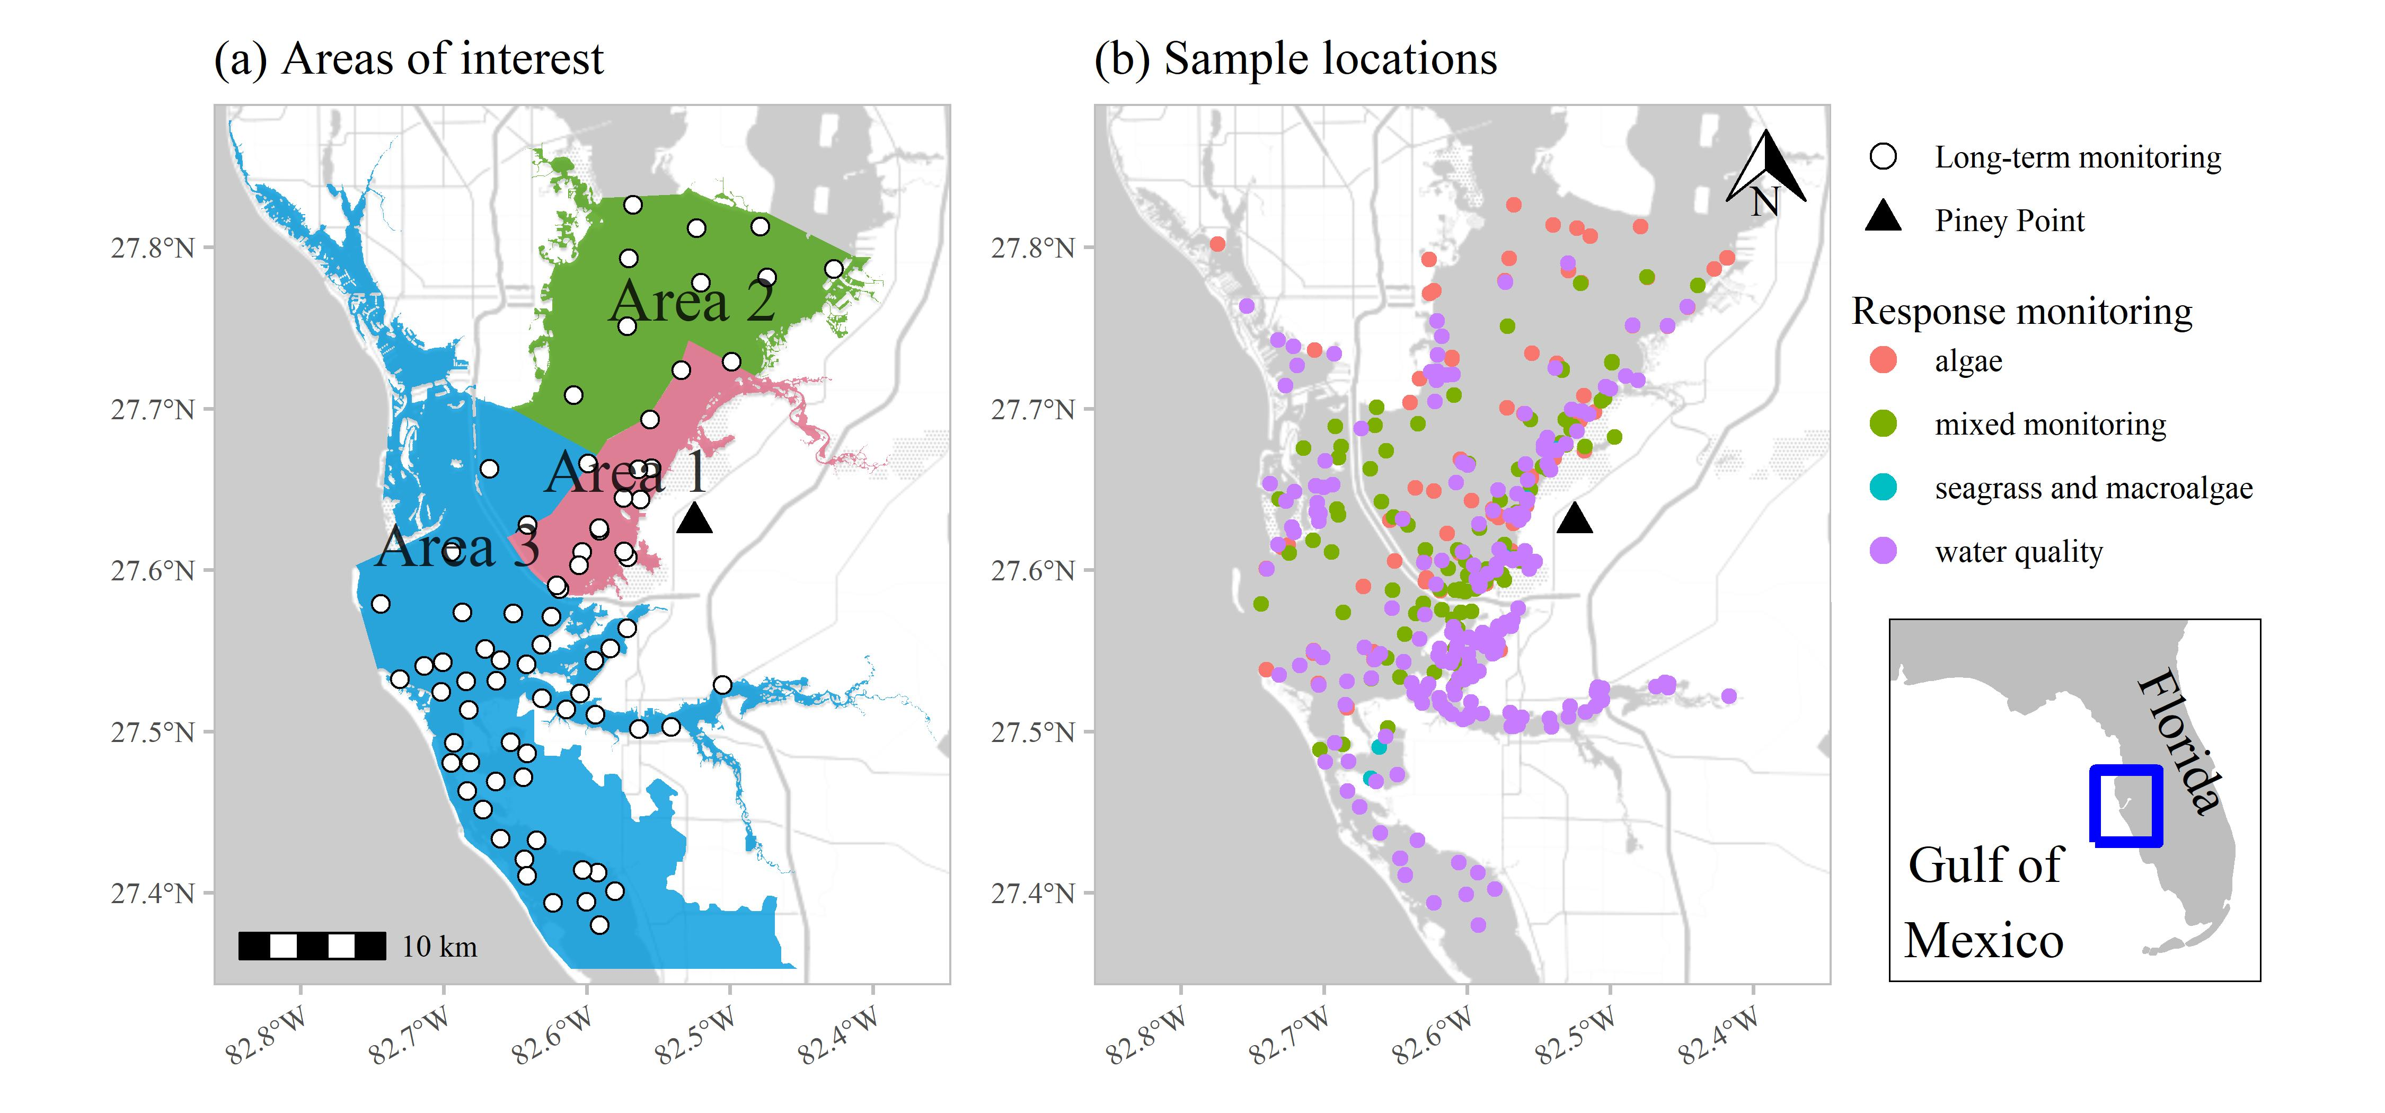

Figure 1: Areas of interest and long-term monitoring stations (a) for evaluating status and trends in response-based monitoring data and sample locations from March to July 2021 by monitoring data type (b) in response to wastewater discharge from Piney Point. Data types include algae sampling, seagrass and macroalgae, water quality (field-based and laboratory samples), and mixed monitoring (algae, seagrass and macroalgae, water quality). Inset shows location of Tampa Bay on the Gulf coast of Florida, USA.

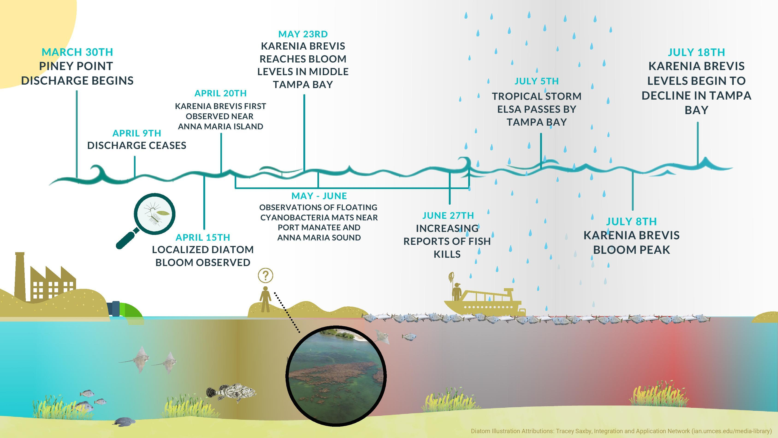

Figure 2: Graphical timeline of events from the discharge of wastewater effluent at Piney Point starting March 30th, 2021 through the end of July with the gradual decline of red tide in Tampa Bay.

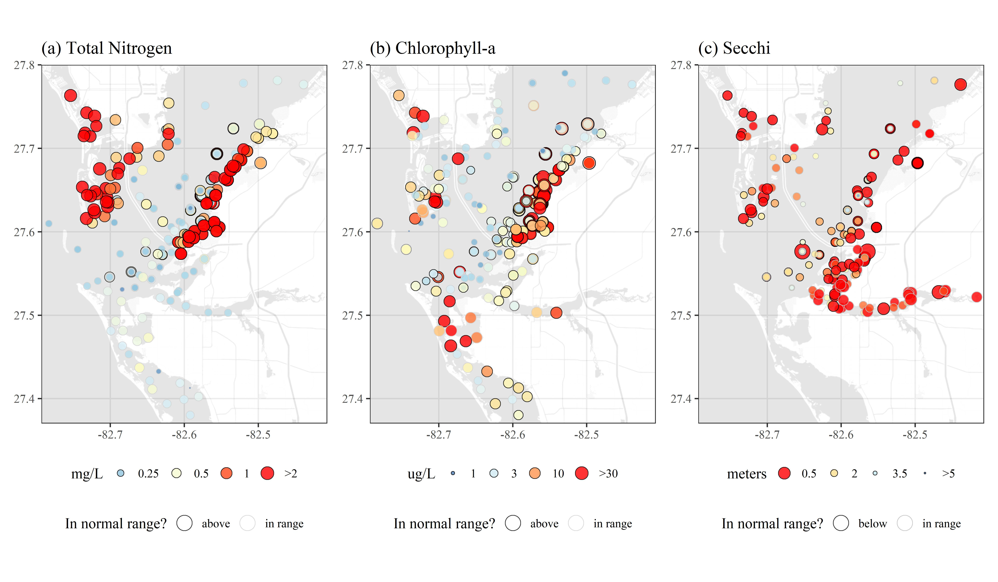

Figure 3: Sampled water quality data for April to July 2021 in response to wastewater discarge from Piney Point for (a) total nitrogen (mg/L), (b) chlorophyll-a (ug/L), and (c) secchi disk depth (meters). Values outside of the normal range (above for total nitrogen and chlorophyll, below for secchi) are outlined in black and those in normal range are outlined in light grey. Color ramps and point sizes show relative values (reversed for Secchi). Normal ranges are defined as within +/-1 standard deviation of the mean for the month of observation from 2006 to 2021 for values collected at the nearest long-term monitoring site to each sample location (Figure 1a). Values below detection limits (or secchi on bottom) are not shown.

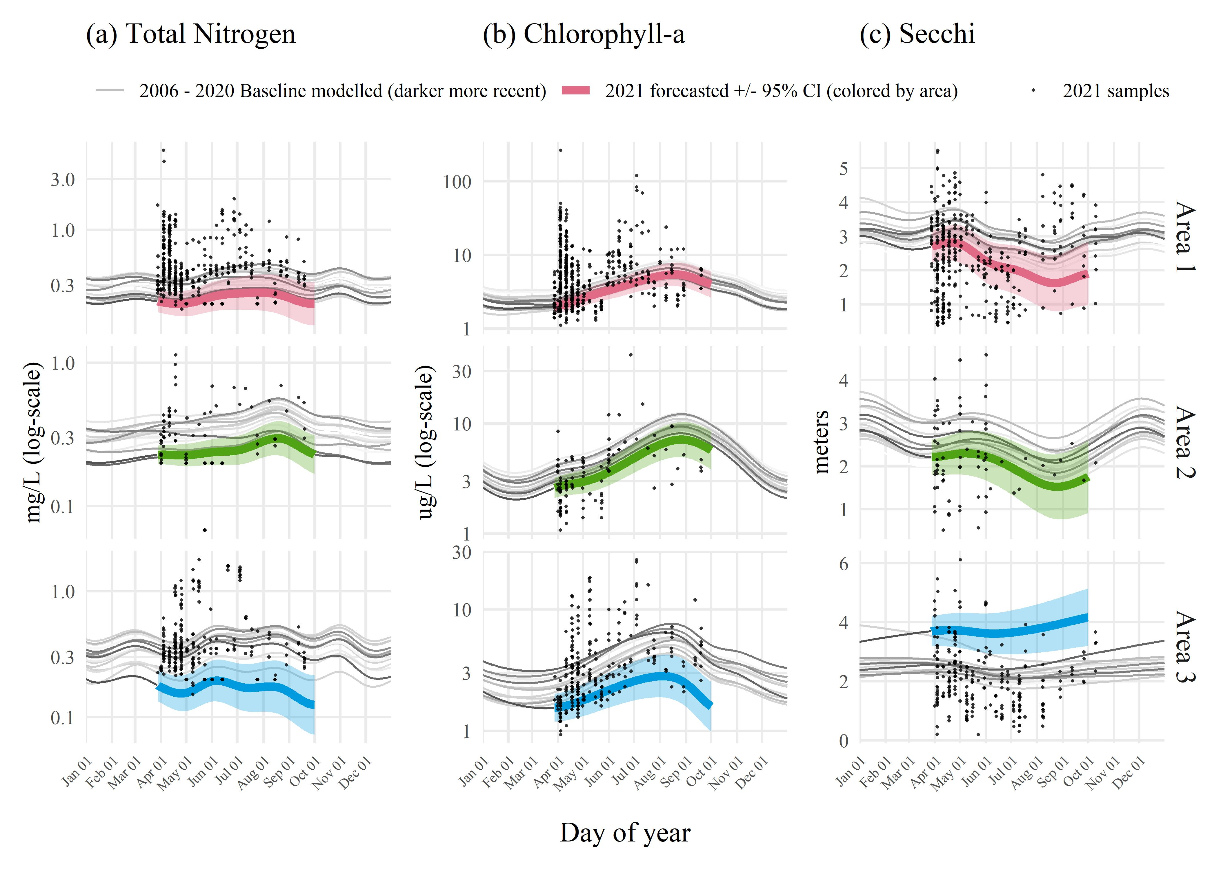

Figure 4: Forecasted 2021 (a) total nitrogen (mg/L), (b) chlorophyll-a (ug/L), and (c) secchi disk depth (meters) by area based on historal seasonal models. Forecasts from the historical models for dates during and after the Piney Point discharge are shown in thick lines (+/- 95% confidence), with observed samples overlaid on the plots to emphasize deviation of 2021 data from historical seasonal estimates. Forecasted values are based on Generalized Additive Models fit to historical baseline data from 2006 to early 2021, with darker lines for more recent years. Results are grouped by assessment areas shown in Figure 1a.

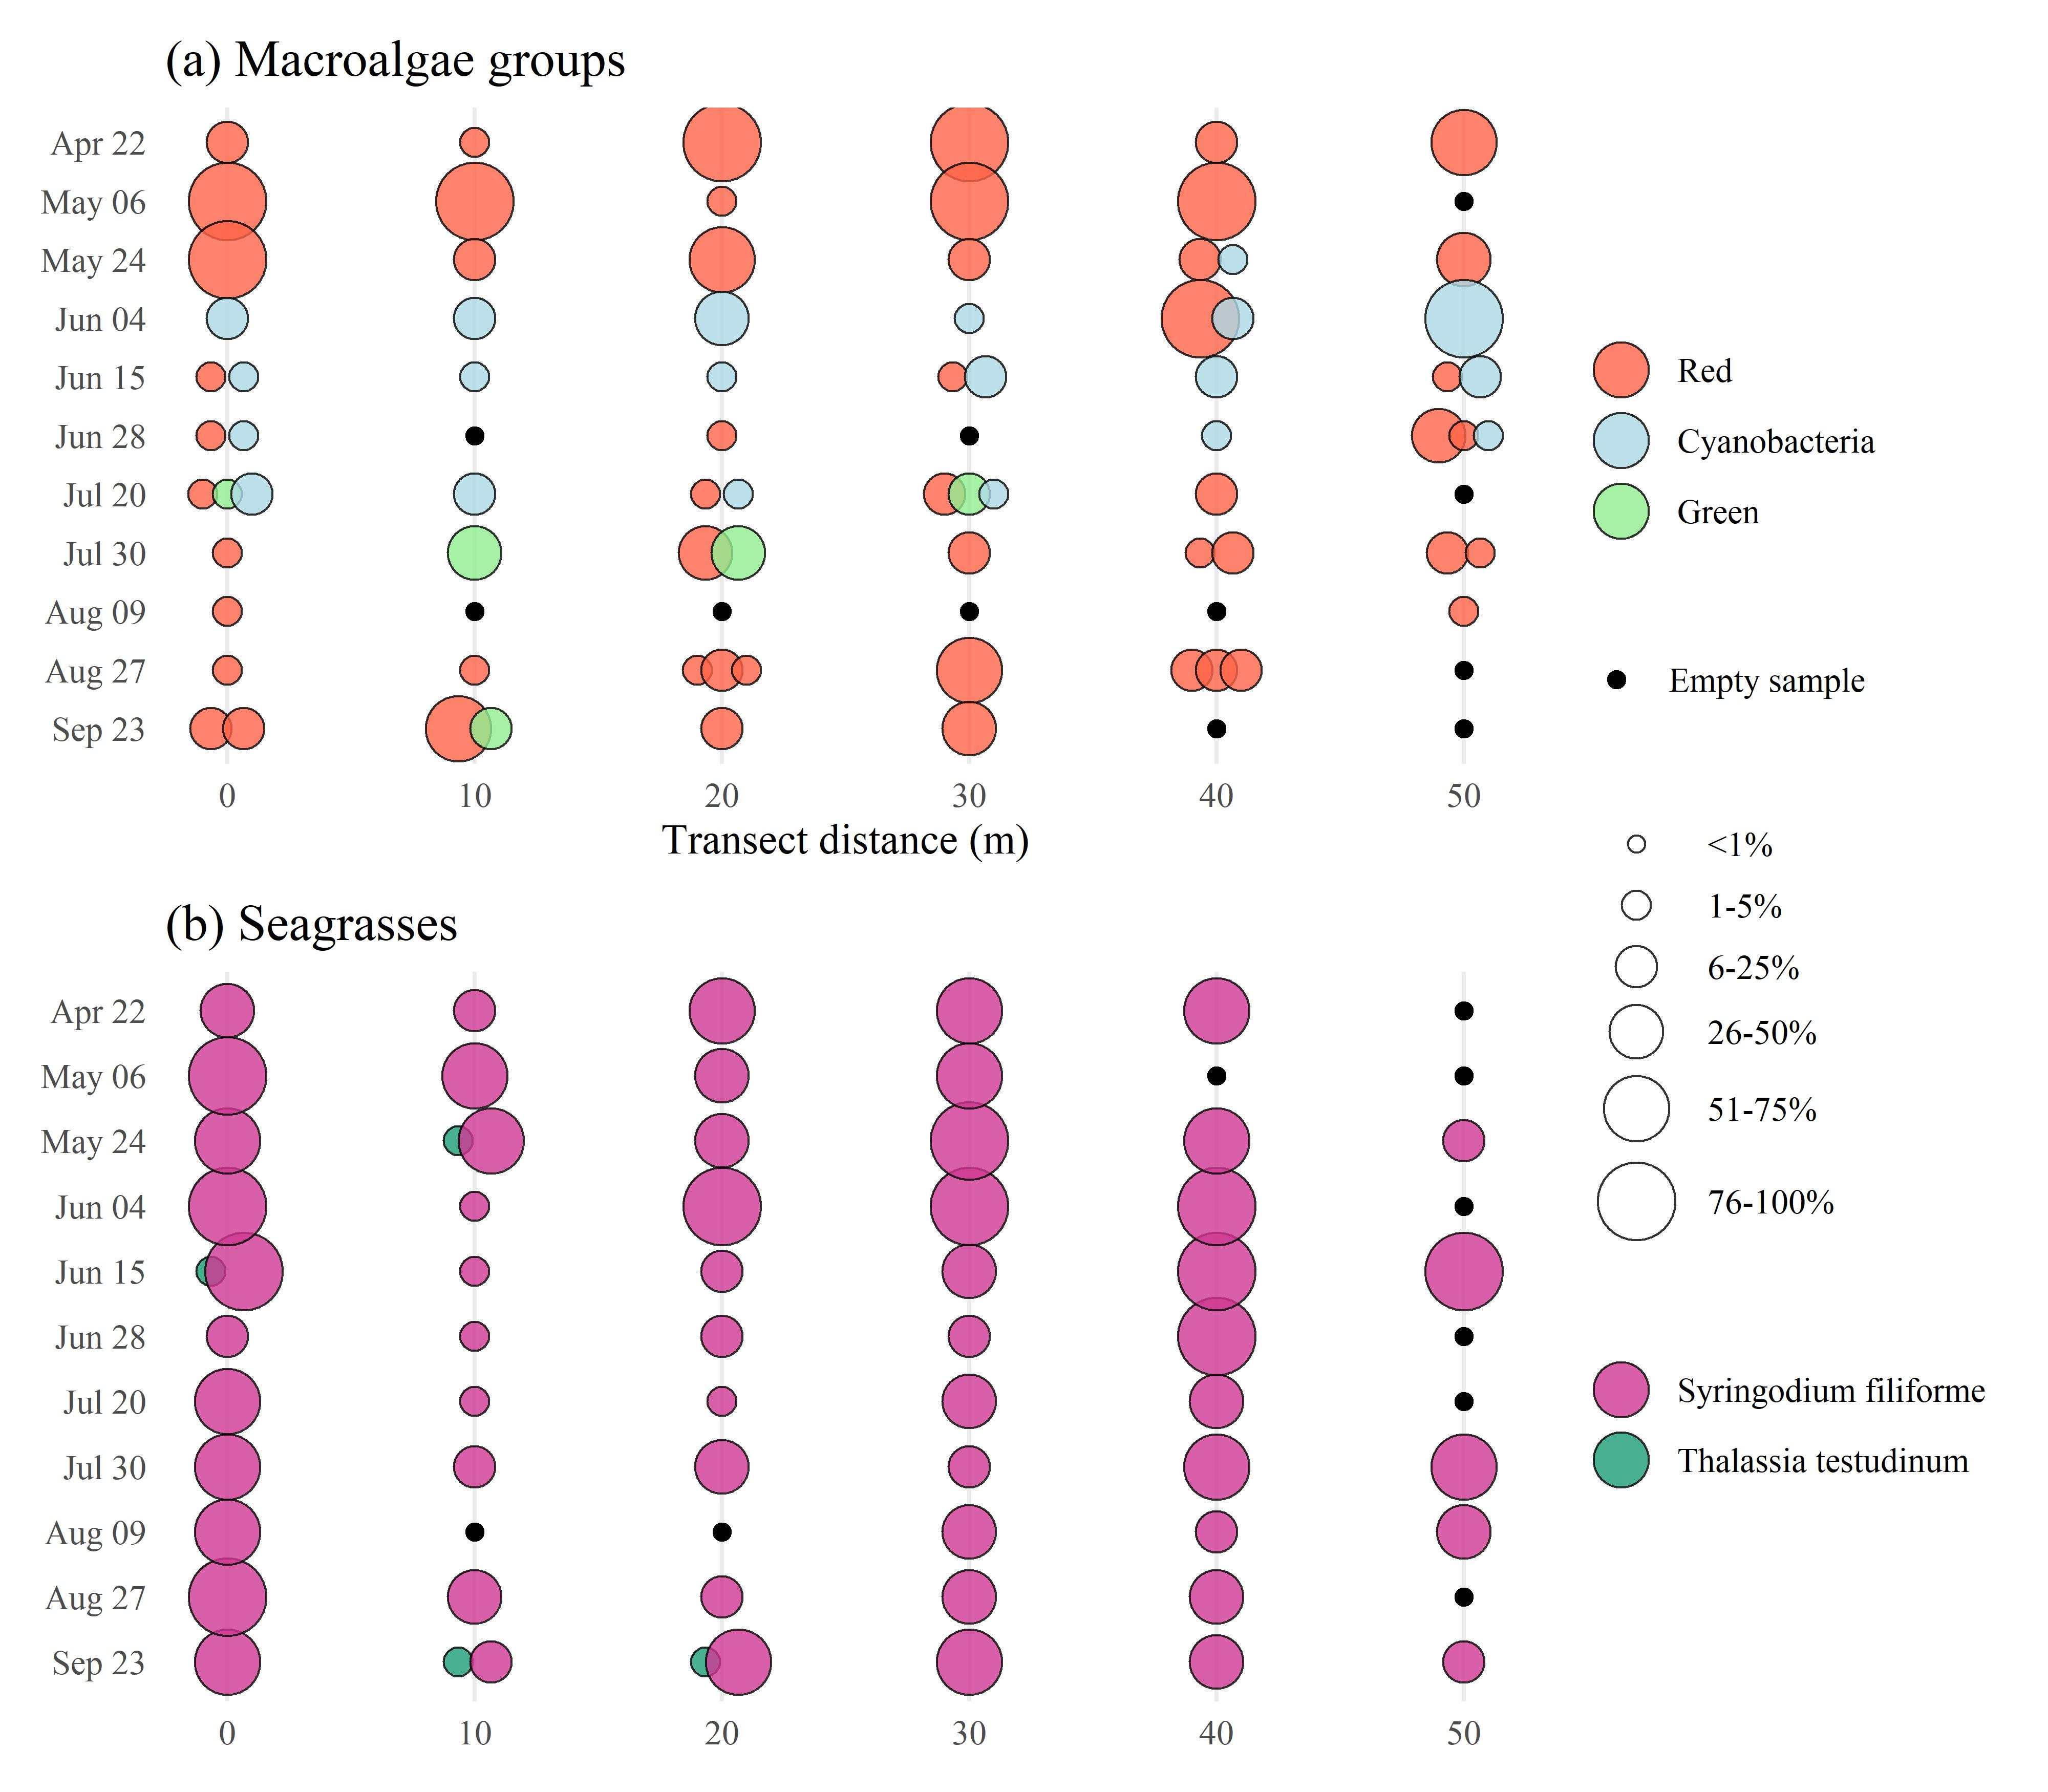

Figure 5: Results for (a) macroalgae and (b) seagrass rapid response transect surveys at a site (S3T6, -82.55866 W longitude, 27.64483 N latitude) near Piney Point. Sample dates in 2021 are shown in rows with transect meter results shown in columns. Results show dominance of manatee grass (*Syringodium filiforme*) and red macroalgae groups, with abundances of *Dapis sp.* (cyanobacteria) peaking in June and green macroalgae (*Ulva spp.*) increasing in July. Abundances are Braun-Blanquet coverage estimates.

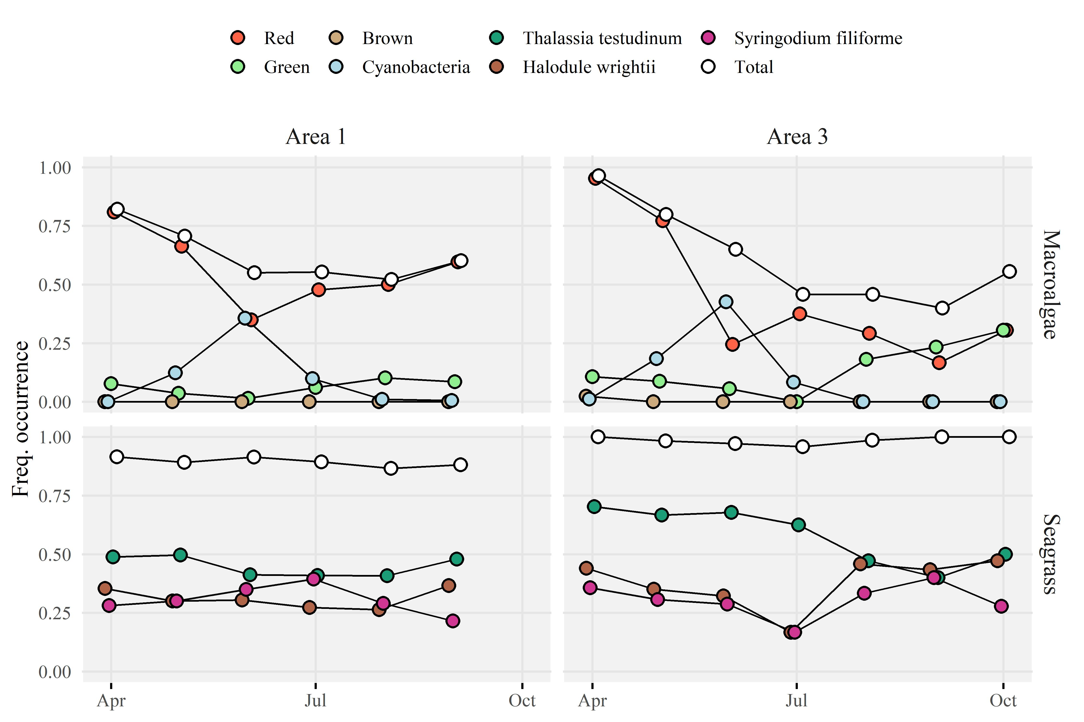

Figure 6: Frequency occurrence estimates for (a) area 1 and (b) area 3 (Figure 1a) for macroalgae (top) and seagrass (bottom) rapid response transect surveys across all transects (n = 38) near Piney Point. Estimates are grouped by sample months in 2021. Frequency occurrences are absolute for each taxa based on presence/absence, whereas the total frequency occurrence applies to any taxa observed on each transect. Points are offset slightly for readability.

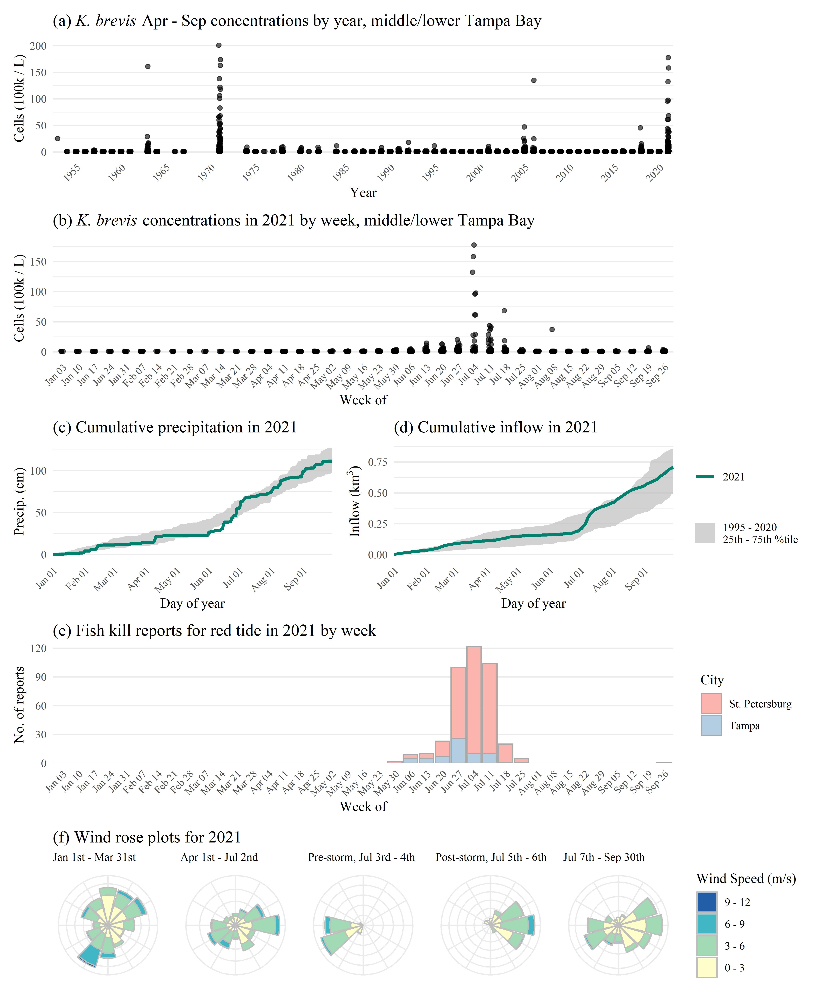

Figure 7: *Karenia brevis* concentrations (100k cells/L) (a) by year and (b) by week in 2021, (c) cumulative precipitation in 2021 compared to past years, (d) cumulative inflow in 2021 compared to past years, (e) fish kill reports in 2021, and (f) wind rose plots for 2021 with notable breaks before/after discharge and tropical storm Elsa. *K. brevis* cell counts are from NOAA Harmful Algal BloomS Observing System (HABSOS, <https://www.ncei.noaa.gov/maps/habsos>), Fish kill reports are from Florida Fish and Wildlife Conservation Commission, Fish and Wildlife Research Insitute Fish Kill Database, attributed to *K. brevis* (<https://public.myfwc.com/FWRI/FishKillReport/>), precipitation data are from Tampa International Airport, inflow estimates are for all of Tampa Bay from USGS gaged sites, and wind rose plots are from St. Petersburg, Florida. Wind roses show relative counts of six minute observations in directional (30 degree bins, north is vertical) and speed (m/s) categories.

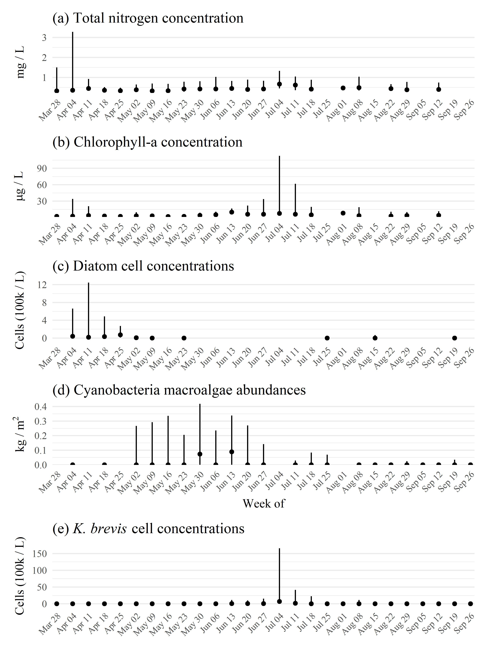

Figure 8: Weekly summarized observations (medians, 2.5th to 97.5th percentiles) across all sampled locations for (a) total nitrogen concentrations, (b) chlorophyll-a concentrations, (c) diatom cell concentrations, (d) cyanobacteria macroalgal abundances, and (e) *Karenia brevis* cell concentrations. Values are summarized for all samples within each week. The values suggest nutrient cycling between water column phytoplankton in the initial April diatom bloom, then to cyanobacteria macroalgae in May to June, and then to *K. brevis* peaking in early July. Quantitative cell counts for diatoms are missing for several weeks, but see supplementary figures for frequency occurence estimates across all dates. Diatom concentrations are based on combined cell counts from *Asterionellopsis sp.* and *Skeletonema sp*.

# Tables

Table 1: Measured concentrations from the phosphogypsum stack (NGS-S) at Piney Point from a 2019 sample and end-of-pipe samples from April 2021 for relevant water quality variables. Values are compared to normal annual medians (min, max) for concentrations in lower Tampa Bay. Normal medians are based on data for a baseline period from 2006 to 2020 from long-term monitoring stations in lower Tampa Bay (Figure 1a). End-of-pipe concentrations were taken as averages from two samples on April 6th and 13th at the outflow at Port Manatee. Missing values were not measured in the effluent or stack water.

|  |  |  |  |
| --- | --- | --- | --- |
| Water quality variable | 2019 stack value | 2021 end-of-pipe value | Bay median (min, max) |
| Nitrate/Nitrite (mg/L) | 0.004 | 0.292 | 0.012 (0.007, 0.014) |
| NH3, NH4+ (mg/L) | 210 | 210 | 0.019 (0.007, 0.039) |
| TN (mg/L) | 230 | 220 | 0.288 (0.226, 0.385) |
| TP (mg/L) | 160 | 150.5 | 0.082 (0.058, 0.145) |
| Ortho-P (mg/L) | 150 | 147.5 | 0.049 (0.029, 0.055) |
| DO (% sat.) | 107.5 | - | 90.7 (86, 92) |
| pH | 4 | - | 8.1 (8, 8.1) |
| Chl-a (ug/L) | - | 105 | 3.1 (2.3, 3.5) |

Table 2: Summary of water quality variables collected in Tampa Bay from March to July 2021 in response to wastewater discharge from Piney Point. Variables are grouped by major areas of interest for evaluating status and trends shown in Figure 1a. Summaries are median, minimum, and maximum values. Total observations (N obs.) and the percentage of observations in range, above, or below normal ranges are also shown. Normal ranges are defined as within +/-1 standard deviation of the mean for the month of observation from 2006 to 2021 for values collected at the nearest long-term monitoring site to each sample location. The final column shows the percentage of total observations that were outside of detection, defined as minimum laboratory detection limits for all parameters and values on the bottom for Secchi observations. Medians denoted by “-” could not be calculated due to insufficient values above detection.

|  |  |  |  |  |  |  |  |
| --- | --- | --- | --- | --- | --- | --- | --- |
| Area | Water quality variable | Med. (Min., Max.) | N obs. | in range | above | below | Below detection |
| 1 | Chl-a (ug/L) | 4.3 (1.1, 265.01) | 485 | 43.5 | 50.1 | 6.4 | 0.0 |
|  | DO (% sat.) | 97.9 (28.3, 215.3) | 430 | 30.0 | 53.3 | 16.7 | 0.0 |
|  | NH3, NH4+ (mg/L) | 0.005 (0, 14.86) | 495 | 65.7 | 17.8 | 16.6 | 26.9 |
|  | Nitrate/Nitrite (mg/L) | 0 (0, 0.14352) | 517 | 63.1 | 19.1 | 17.8 | 70.2 |
|  | pH | 8.1 (6.8, 9.1) | 476 | 57.6 | 28.8 | 13.7 | 0.0 |
|  | Sal (ppt) | 30.2 (12.9, 34.6) | 441 | 83.0 | 4.3 | 12.7 | 0.0 |
|  | Secchi (m) | 2.6 (0.5, 9.5) | 263 | 44.1 | 22.1 | 33.8 | 0.0 |
|  | Temp (C) | 25.5 (19.6, 32.9) | 442 | 65.6 | 15.4 | 19.0 | 0.0 |
|  | TN (mg/L) | 0.41 (0.178, 5.6) | 430 | 58.4 | 37.2 | 4.4 | 4.0 |
|  | TP (mg/L) | 0.12 (0.019, 3.9) | 485 | 81.0 | 15.1 | 3.9 | 0.8 |
| 2 | Chl-a (ug/L) | 2.7 (1.08, 42) | 78 | 60.3 | 6.4 | 33.3 | 0.0 |
|  | DO (% sat.) | 95 (60.6, 153.3) | 73 | 42.5 | 43.8 | 13.7 | 0.0 |
|  | NH3, NH4+ (mg/L) | 0.004 (0.002, 0.071) | 76 | 85.5 | 1.3 | 13.2 | 27.6 |
|  | Nitrate/Nitrite (mg/L) | - (0.00078, 0.037) | 87 | 63.2 | 18.4 | 18.4 | 80.5 |
|  | pH | 8 (7.3, 8.6) | 92 | 71.7 | 16.3 | 12.0 | 0.0 |
|  | Sal (ppt) | 27.3 (18.1, 32.3) | 73 | 90.4 | 0.0 | 9.6 | 0.0 |
|  | Secchi (m) | 2 (0.5, 3.5) | 27 | 51.9 | 29.6 | 18.5 | 0.0 |
|  | Temp (C) | 25.3 (19.9, 31.6) | 73 | 72.6 | 6.8 | 20.5 | 0.0 |
|  | TN (mg/L) | 0.344 (0.068, 1.13) | 63 | 65.1 | 22.2 | 12.7 | 14.3 |
|  | TP (mg/L) | 0.1 (0.05, 0.235) | 67 | 59.7 | 11.9 | 28.4 | 0.0 |
| 3 | Chl-a (ug/L) | 2.9 (0.93, 25.9) | 254 | 68.9 | 22.4 | 8.7 | 0.4 |
|  | DO (% sat.) | 98.7 (42.4, 229.9) | 223 | 52.9 | 26.5 | 20.6 | 0.0 |
|  | NH3, NH4+ (mg/L) | 0.003 (0.002, 0.041) | 248 | 54.8 | 0.0 | 45.2 | 54.8 |
|  | Nitrate/Nitrite (mg/L) | - (0.00078, 0.046) | 267 | 59.9 | 9.4 | 30.7 | 92.9 |
|  | pH | 8.1 (6.2, 14.4) | 246 | 69.5 | 21.1 | 9.3 | 0.0 |
|  | Sal (ppt) | 31.8 (1.4, 36.5) | 294 | 81.0 | 7.8 | 11.2 | 0.0 |
|  | Secchi (m) | 1.9 (0.2, 5.1) | 200 | 48.5 | 16.5 | 35.0 | 0.0 |
|  | Temp (C) | 27 (19.6, 32.1) | 294 | 63.6 | 12.6 | 23.8 | 0.0 |
|  | TN (mg/L) | 0.33 (0.152, 1.78) | 249 | 73.1 | 21.7 | 5.2 | 10.0 |
|  | TP (mg/L) | 0.06 (0.019, 0.589) | 256 | 77.7 | 10.5 | 11.7 | 17.6 |

Table 3: Comparison of total nitrogen, chlorophyll-a, and secchi depth by areas of interest (Figure 1a) and month. Overall signifance of differences of concentrations between months for each water quality variable and area combination are shown with Chi-squared statistics based on Kruskall-Wallis rank sum tests. Multiple comparisons with Mann-Whitney U tests (Comp. column) were used to evaluate pairwise monthly concentrations for each water quality variable in each area. Rows that share a letter within each area and water quality variable combination have concentrations that are not significantly different between month pairs. Probability values were adjusted for the pairwise comparisons using the Bonferroni method in Holm (1979). ** p < 0.005, * p < 0.05, blank is not significant at $α$ = 0.05.

|  |  |  |  |  |  |  |  |
| --- | --- | --- | --- | --- | --- | --- | --- |
| Area | Water quality variable | Chi-Sq. | Comp. | Month | N obs. | Observed median | Seasonally-corrected median |
| 1 | TN (mg/L) | 25.01** | a | Apr | 135 | 0.390 | 0.008 |
|  |  |  | b | May | 32 | 0.360 | 0.110 |
|  |  |  | ab | Jun | 38 | 0.430 | 0.112 |
|  |  |  | b | Jul | 24 | 0.520 | 0.178 |
|  |  |  | ab | Aug | 25 | 0.470 | 0.065 |
|  |  |  | ab | Sep | 8 | 0.390 | 0.075 |
|  | Chl-a (ug/L) | 61.84** | a | Apr | 144 | 3.300 | 1.010 |
|  |  |  | b | May | 32 | 2.400 | -0.870 |
|  |  |  | a | Jun | 38 | 6.600 | 1.960 |
|  |  |  | a | Jul | 24 | 5.600 | 0.310 |
|  |  |  | c | Aug | 27 | 3.300 | -3.590 |
|  | Secchi (m) | 47.47** | a | Apr | 118 | 2.900 | 0.000 |
|  |  |  | b | May | 28 | 3.000 | -0.600 |
|  |  |  | b | Jun | 34 | 2.000 | -0.900 |
|  |  |  | b | Jul | 18 | 2.000 | -0.700 |
|  |  |  | c | Aug | 15 | 3.500 | 0.400 |
|  |  |  | c | Sep | 12 | 3.600 | 0.900 |
| 2 | TN (mg/L) | 20.85** | a | Apr | 18 | 0.390 | -0.002 |
|  |  |  | b | May | 4 | 0.390 | 0.160 |
|  |  |  | ab | Jun | 3 | 0.500 | 0.113 |
|  |  |  | ab | Jul | 3 | 0.510 | 0.097 |
|  |  |  | ab | Aug | 3 | 0.540 | 0.174 |
|  |  |  | ab | Sep | 1 | 0.570 | 0.049 |
|  | Chl-a (ug/L) | 10.76* | a | Apr | 22 | 2.500 | -1.390 |
|  |  |  | a | May | 4 | 2.150 | -2.590 |
|  |  |  | a | Jun | 4 | 6.000 | -1.050 |
|  |  |  | a | Jul | 3 | 7.200 | -0.940 |
|  |  |  | a | Aug | 3 | 5.200 | -4.940 |
|  | Secchi (m) | 3.82 | a | Apr | 17 | 2.000 | 0.200 |
|  |  |  | a | May | 1 | 2.000 | 0.500 |
|  |  |  | a | Jun | 3 | 2.100 | 0.700 |
|  |  |  | a | Jul | 1 | 1.400 | -0.100 |
| 3 | TN (mg/L) | 22.13** | a | Apr | 48 | 0.330 | -0.010 |
|  |  |  | b | May | 16 | 0.335 | 0.079 |
|  |  |  | ab | Jun | 10 | 0.350 | -0.087 |
|  |  |  | ab | Jul | 12 | 0.365 | 0.043 |
|  |  |  | ab | Aug | 4 | 0.435 | 0.126 |
|  |  |  | ab | Sep | 7 | 0.380 | 0.023 |
|  | Chl-a (ug/L) | 33.62** | ab | Apr | 48 | 1.900 | -0.900 |
|  |  |  | ac | May | 16 | 2.350 | -0.450 |
|  |  |  | b | Jun | 12 | 2.800 | -1.580 |
|  |  |  | cd | Jul | 8 | 4.150 | 0.770 |
|  |  |  | bd | Aug | 4 | 3.200 | -3.100 |
|  |  |  | abcd | Sep | 8 | 3.600 | -1.500 |
|  | Secchi (m) | 8.77 | a | Apr | 41 | 2.700 | 0.000 |
|  |  |  | a | May | 16 | 2.200 | -0.500 |
|  |  |  | a | Jun | 12 | 2.200 | -0.400 |
|  |  |  | a | Jul | 12 | 2.200 | -0.100 |
|  |  |  | a | Aug | 3 | 2.000 | -0.800 |
|  |  |  | a | Sep | 11 | 2.200 | 0.000 |

# References

Ahern, K.S., Ahern, C.R., Udy, J.W., 2007. Nutrient additions generate prolific growth of Lyngbya majuscula (cyanobacteria) in field and bioassay experiments. Harmful Algae 6, 134–151. <https://doi.org/10.1016/j.hal.2006.08.004>

Albert, S., O’Neil, J.M., Udy, J.W., Ahern, K.S., O’Sullivan, C.M., Dennison, W.C., 2005. Blooms of the cyanobacterium Lyngbya majuscula in coastal Queensland, Australia: Disparate sites, common factors. Marine Pollution Bulletin 51, 428–437. <https://doi.org/10.1016/j.marpolbul.2004.10.016>

Bates, S.S., 1976. Effects of light and ammonium on nitrate uptake by two species of estuarine phytoplankton. Limnology and oceanography 21, 212–218. <https://doi.org/10.4319/lo.1976.21.2.0212>

Beck, M.W., Cressman, K., Griffin, C., Caffrey, J., 2018a. Water quality trends following anomalous phosphorus inputs to Grand Bay. Gulf and Caribbean Research 29, 1–14. <https://doi.org/10.18785/gcr.2901.02>

Beck, M.W., Hagy, J.D., III, Le, C., 2018b. Quantifying seagrass light requirements using an algorithm to spatially resolve depth of colonization. Estuaries and Coasts 41, 592–610. <https://doi.org/10.1007/s12237-017-0287-1>

Beck, M.W., Schrandt, M., Wessel, M., Sherwood, E., Raulerson, G., Best, B., 2021. Tbeptools: Data and indicators for the tampa bay estuary program.

Bryan, J., 2020. googlesheets4: Access google sheets using the sheets API V4.

Burke, M., 2017. CCMP Climate Change Vulnerability Assessment (No. 10b-17). Tampa Bay Estuary Program, St. Petersburg, Florida.

Burnett, W.C., Elzerman, A.W., 2001. Nuclide migration and the environmental radiochemistry of florida phosphogypsum. Journal of Environmental Radioactivity 54, 27–51. <https://doi.org/10.1016/S0265-931X(00)00164-8>

Caffrey, J.M., Murrell, M.C., Amacker, K.S., Harper, J., Phipps, S., Woodrey, M., 2013. Seasonal and inter-annual patterns in primary production, respiration and net ecosystem metabolism in 3 estuaries in the northeast Gulf of Mexico. Estuaries and Coasts 37, 222–241. <https://doi.org/10.1007/s12237-013-9701-5>

Chen, J., Weisberg, R.H., Liu, Y., Zheng, L., 2018. The Tampa Bay Coastal Ocean Model performance for Hurricane Irma. Marine Technology Society Journal 52, 33–42. <https://doi.org/10.4031/MTSJ.52.3.6>

Chen, J., Weisberg, R.H., Liu, Y., Zheng, L., Zhu, J., 2019. On the momentum balance of tampa bay. Journal of Geophysical Research: Oceans 124, 4492–4510. <https://doi.org/10.1029/2018JC014890>

Cohen, R.A., Fong, P., 2006. Using opportunistic green macroalgae as indicators of nitrogen supply and sources to estuaries. Ecological Applications 16, 1405–1420. <https://doi.org/10.1890/1051-0761(2006)016[1405:UOGMAI]2.0.CO;2>

D’Agostino McGowan, L., Bryan, J., 2020. Googledrive: An interface to google drive.

Dillon, K., Caffrey, J., Carmichael, R.H., Cressman, K., Woodrey, M., 2015. Water quality in Bangs Lake: Effects of recurrent phosphate spills to a coastal estuary. Mississippi Water Resources Research Institute, Mississippi State, US Geological Survey, Starkville, Mississippi.

Dixon, L.K., Leverone, J.R., 1995. Light requirements of *thalassia testudinum* in Tampa Bay, Florida. Number 425, Mote Marine Lab, Sarasota, Florida.

Doering, P.H., Chamberlain, R.H., Haunert, K.M., 2006. Chlorophyll a and its use as an indicator of eutrophication in the Caloosahatchee Estuary, Florida. Florida Scientist 51–72. https://doi.org/<https://www.jstor.org/stable/24322132>

Domingues, R.B., Barbosa, A.B., Sommer, U., Galvão, H.M., 2011. Ammonium, nitrate and phytoplankton interactions in a freshwater tidal estuarine zone: Potential effects of cultural eutrophication. Aquatic sciences 73, 331–343. <https://doi.org/10.1007/s00027-011-0180-0>

El Zrelli, R., Courjault-Radé, P., Rabaoui, L., Castet, S., Michel, S., Bejaoui, N., 2015. Heavy metal contamination and ecological risk assessment in the surface sediments of the coastal area surrounding the industrial complex of Gabes city, Gulf of Gabes, SE Tunisia. Marine pollution bulletin 101, 922–929. <https://doi.org/10.1016/j.marpolbul.2015.10.047>

Estrella, S.M., 2013. Effects of nutrient enrichment and toxic Lyngbya blooms on benthic invertebrates and migratory shorebird communities of Roebuck Bay Ramsar site, Final Report to the NRM Office, WA. University of Western Australia, Perth, Australia.

Flaherty, K.E., Landsberg, J.H., 2011. Effects of a persistent red tide *karenia brevis* bloom on community structure and species-specific relative abundance of nekton in a Gulf of Mexico estuary. Estuaries and Coasts 34, 417–439. <https://doi.org/10.1007/s12237-010-9350-x>

Garrett, M., Wolny, J., Truby, E., Heil, C., Kovach, C., 2011. Harmful algal bloom species and phosphate-processing effluent: Field and laboratory studies. Marine Pollution Bulletin 62, 596–601. <https://doi.org/10.1016/j.marpolbul.2010.11.017>

Gillett, D.J., Gilbane, L., Schiff, K.C., 2021. Characterizing community structure of benthic infauna from the continental slope of the Southern California Bight. Frontiers in Marine Science 8, 61. <https://doi.org/10.3389/fmars.2021.605858>

Greening, H., Janicki, A., 2006. Toward reversal of eutrophic conditions in a subtropical estuary: Water quality and seagrass response to nitrogen loading reductions in Tampa Bay, Florida, USA. Environmental Management 38, 163–178. <https://doi.org/10.1007/s00267-005-0079-4>

Greening, H., Janicki, A., Sherwood, E., 2016. Seagrass recovery in Tampa Bay, Florida (USA), in: Finlayson, C.M., Milton, G.R., Prentice, R.C., Davidson, N.C. (Eds.), The Wetland Book. Springer, Berlin, Germany, pp. 1–12.

Greening, H., Janicki, A., Sherwood, E., Pribble, R., Johansson, J.O.R., 2014. Ecosystem responses to long-term nutrient management in an urban estuary: Tampa Bay, Florida, USA. Estuarine, Coastal and Shelf Science 151, A1–A16. <https://doi.org/10.1016/j.ecss.2014.10.003>

Helsel, D.R., 2005. Nondectects and data analysis: Statistics for censored environmental data. John Wiley & Sons, New Jersey, USA.

Henderson, C.S., 2004. Piney Point phosphate plant: An environmental analysis.

Hollander, M., Wolfe, D.A., Chicken, E., 2013. Nonparametric statistical methods. John Wiley & Sons.

Holm, S., 1979. A simple sequentially rejective multiple test procedure. Scandinavian journal of statistics 65–70.

Howarth, R.W., Marino, R., 2006. Nitrogen as the limiting nutrient for eutrophication in coastal marine ecosystems: Evolving views over three decades. Limnology and oceanography 51, 364–376. <https://doi.org/10.4319/lo.2006.51.1_part_2.0364>

Hudson-Edwards, K.A., Jamieson, H.E., Lottermoser, B.G., 2011. Mine wastes: Past, present, future. Elements 7, 375–380. <https://doi.org/10.2113/gselements.7.6.375>

Janicki, A., Wade, D., 1996. Estimating critical external nitrogen loads for the Tampa Bay estuary: An empirically based approach to setting management targets (No. 06-96). Tampa Bay National Estuary Program, St. Petersburg, Florida.

Janicki Environmental, Inc., 2017a. Estimates of total nitrogen, total phosphorus, total suspended solids, and biological oxygen demand loadings to Tampa Bay, Florida: 2012-2016 (No. 04-17). Tampa Bay Estuary Program, St. Petersburg, Florida.

Janicki Environmental, Inc., 2017b. Estimates of total nitrogen, total phosphorus, total suspended solids, and biological oxygen demand loadings to Tampa Bay, Florida: 2012-2016 (No. 04-17). Tampa Bay Estuary Program, St. Petersburg, Florida.

Janicki Environmental, Inc., 2008. Estimation of nitrogen loading from residential irrigation. Tampa Bay Estuary Program, St. Petersburg, Florida.

Karlen, D.J., Dix, T., Goetting, B.K., Markham, S.E., K.Campbell, Jernigan, J., J.Christian, Martinez, K., Chacour, A., 2020. Twenty-five-year trends in the benthic community and sediment quality of Tampa Bay 1993-2017 (No. 06-20). Tampa Bay Estuary Program, St. Petersburg, Florida.

Kenworthy, W.J., Fonseca, M.S., 1996. Light requirements of seagrasses *halodule wrightii* and *syringodium filiforme* derived from the relationship between diffuse light attenuation and maximum depth distribution. Estuaries 19, 740–750.

Lee, L., 2020. NADA: Nondetects and data analysis for environmental data.

Liu, Y., Weisberg, R.H., Lenes, J.M., Zheng, L., Hubbard, K., Walsh, J.J., 2016. Offshore forcing on the "pressure point" of the West Florida Shelf: Anomalous upwelling and its influence on harmful algal blooms. Journal of Geophysical Research: Oceans 121, 5501–5515. <https://doi.org/10.1002/2016JC011938>

Lloret, J., Marin, A., Marin-Guirao, L., Velasco, J., 2005. Changes in macrophytes distribution in a hypersaline coastal lagoon associated with the development of intensively irrigated agriculture. Ocean & Coastal Management 48, 828–842. <https://doi.org/10.1016/j.ocecoaman.2005.07.002>

Medina, M., Huffaker, R., Jawitz, J.W., Muñoz-Carpena, R., 2020. Seasonal dynamics of terrestrially sourced nitrogen influenced Karenia brevis blooms off Florida’s southern Gulf Coast. Harmful Algae 98, 101900. <https://doi.org/10.1016/j.hal.2020.101900>

Murphy, R.R., Perry, E., Harcum, J., Keisman, J., 2019. A Generalized Additive Model Approach to evaluating water quality: Chesapeake Bay case study. Environmental Modelling & Software 118, 1–13. <https://doi.org/10.1016/j.envsoft.2019.03.027>

Nixon, S.W., 1995. Coastal marine eutrophication: A definition, social causes, and future concerns. Ophelia 41, 199–219. <https://doi.org/10.1080/00785236.1995.10422044>

Parker, A.E., Hogue, V.E., Wilkerson, F.P., Dugdale, R.C., 2012. The effect of inorganic nitrogen speciation on primary production in the San Francisco Estuary. Estuarine, Coastal, and Shelf Science 104, 91–101.

Pebesma, E., 2018. Simple features for R: Standardized support for spatial vector data. The R Journal 10, 439–446. <https://doi.org/10.32614/RJ-2018-009>

Pérez-López, R., Macı́as, F., Cánovas, C.R., Sarmiento, A.M., Pérez-Moreno, S.M., 2016. Pollutant flows from a phosphogypsum disposal area to an estuarine environment: An insight from geochemical signatures. Science of the Total Environment 553, 42–51. <https://doi.org/10.1016/j.scitotenv.2016.02.070>

Pérez-López, R., Nieto, J.M., López-Coto, I., Aguado, J.L., Bolı́var, J.P., Santisteban, M., 2010. Dynamics of contaminants in phosphogypsum of the fertilizer industry of Huelva (SW Spain): From phosphate rock ore to the environment. Applied Geochemistry 25, 705–715. <https://doi.org/10.1016/j.apgeochem.2010.02.003>

Poor, N., Cross, L., Dennis, R., 2013. Lessons learned from the Bay Region Atmospheric Chemistry Experiment (BRACE) and implications for nitrogen management of Tampa Bay. Atmospheric Environment 70, 75–83. <https://doi.org/10.1016/j.atmosenv.2012.12.030>

R Core Team, 2020. R: A language and environment for statistical computing, v4.0.3. R Foundation for Statistical Computing, Vienna, Austria.

Sanders, L., Luiz-Silva, W., Machado, W., Sanders, C.J., Marotta, H., Enrich-Prast, A., Bosco-Santos, A., Boden, A., Silva-Filho, E., Santos, I.R., others, 2013. Rare earth element and radionuclide distribution in surface sediments along an estuarine system affected by fertilizer industry contamination. Water, Air, & Soil Pollution 224, 1–8. <https://doi.org/10.1007/s11270-013-1742-7>

Schrandt, M.N., MacDonald, T.C., Sherwood, E.T., Beck, M.W., 2021. A multimetric nekton index for monitoring, managing and communicating ecosystem health status in an urbanized Gulf of Mexico estuary. Ecological Indicators 123, 107310. <https://doi.org/10.1016/j.ecolind.2020.107310>

Sherwood, E., Greening, H., 2014. Potential impacts and management implications of climate change on Tampa Bay estuary critical coastal habitats. Environmental Management 53, 401–415. <https://doi.org/10.1007/s00267-013-0179-5>

Sherwood, E., Greening, H., Johansson, J.O.R., Kaufman, K., Raulerson, G., 2017. Tampa Bay (Florida, USA): Documenting seagrass recovery since the 1980’s and reviewing the benefits. Southeastern Geographer 57, 294–319. <https://doi.org/10.1353/sgo.2017.0026>

Skripnikov, A., Wagner, N., Shafer, J., Beck, M., Sherwood, E., Burke, M., 2021. Using localized Twitter activity to assess harmful algal bloom impacts of Karenia brevis in Florida, USA. Harmful Algae 110, 102118. <https://doi.org/10.1016/j.hal.2021.102118>

Stafford, N.B., Bell, S.S., 2006. Space competition between seagrass and Caulerpa prolifera (Forsskaal) Lamouroux following simulated disturbances in Lassing Park, FL. Journal of Experimental Marine Biology and Ecology 333, 49–57. <https://doi.org/10.1016/j.jembe.2005.11.025>

Steidinger, K.A., 1975. Implications of dinoflagellate life cycles on initiation of Gymnodinium breve red tides. Environmental letters 9, 129–139. <https://doi.org/10.1080/00139307509435842>

Steidinger, K.A., Ingle, R.M., 1972. Observations on the 1971 summer red tide in Tampa Bay, Florida. Environmental Letters 3, 271–278. <https://doi.org/10.1080/00139307209435473>

Switzer, T.S., Tyler-Jedlund, A.J., Rogers, K.R., Grier, H., McMichael Jr, R.H., Fox, S., 2011. Response of estuarine nekton to the regulated discharge of treated phosphate-production process water. Florida Fish; Wildlife Conservation Commission, Fish; Wildlife Research Institute, St. Petersburg, Florida.

Tayibi, H., Choura, M., López, F.A., Alguacil, F.J., López-Delgado, A., 2009. Environmental impact and management of phosphogypsum. Journal of Environmental Management 90, 2377–2386. <https://doi.org/10.1016/j.jenvman.2009.03.007>

Tomasko, D., Alderson, M., Burnes, R., Hecker, J., Iadevaia, N., Leverone, J., Raulerson, G., Sherwood, E., 2020. The effects of Hurricane Irma on seagrass meadows in previously eutrophic estuaries in Southwest Florida (USA). Marine Pollution Bulletin 156, 111247. <https://doi.org/10.1016/j.marpolbul.2020.111247>

Tomasko, D., Alderson, M., Burnes, R., Hecker, J., Leverone, J., Raulerson, G., Sherwood, E., 2018. Widespread recovery of seagrass coverage in Southwest Florida (USA): Temporal and spatial trends and management actions responsible for success. Marine Pollution Bulletin 135, 1128–1137. <https://doi.org/10.1016/j.marpolbul.2018.08.049>

Valiela, I., McClelland, J., Hauxwell, J., Behr, P.J., Hersh, D., Foreman, K., 1997. Macroalgal blooms in shallow estuaries: Controls and ecophysiological and ecosystem consequences. Limnology and oceanography 42, 1105–1118. <https://doi.org/10.4319/lo.1997.42.5_part_2.1105>

Wade, D., Malloy, K., Janicki, A., Nijbroek, R., Grabe, S., 2006. Development of a benthic index to establish sediment quality targets for the Tampa Bay estuary (No. 01-06). Tampa Bay Estuary Program, St. Petersburg, Florida.

Weisberg, R.H., Liu, Y., Lembke, C., Hu, C., Hubbard, K., Garrett, M., 2019. The coastal ocean circulation influence on the 2018 West Florida Shelf K. Brevis red tide bloom. Journal of Geophysical Research: Oceans 124, 2501–2512. <https://doi.org/10.1029/2018JC014887>

Weisberg, R.H., Zheng, L., Liu, Y., Lembke, C., Lenes, J.M., Walsh, J.J., 2014. Why no red tide was observed on the West Florida Continental Shelf in 2010. Harmful Algae 38, 119–126. <https://doi.org/10.1016/j.hal.2014.04.010>

Wickham, H., Averick, M., Bryan, J., Chang, W., McGowan, L.D., François, R., Grolemund, G., Hayes, A., Henry, L., Hester, J., Kuhn, M., Pedersen, T.L., Miller, E., Bache, S.M., Müller, K., Ooms, J., Robinson, D., Seidel, D.P., Spinu, V., Takahashi, K., Vaughan, D., Wilke, C., Woo, K., Yutani, H., 2019. Welcome to the tidyverse. Journal of Open Source Software 4, 1686. <https://doi.org/10.21105/joss.01686>

Wood, S.N., 2017. Generalized additive models: An introduction with r, 2nd ed. Chapman; Hall, CRC Press, London, United Kingdom.